  St. Peter’s Cathedral  Helena, Montana  The Rt. Rev. Marty Stebbins, Bishop  The Very Rev. Kendra Wilde, Dean  Welcome  We’re so glad you’re here today. Whether you’ve been worshiping here for years or it’s your first time, we hope you find richness in offering your prayers and praise with others in this holy space. Afterward, please join us downstairs for a snack, fellowship, and a time for conversation. Whoever you are, wherever you have been, wherever you hurt, whatever joys and concerns you bring today, you are welcome at Christ’s table and here at St. Peter’s Cathedral.  We draw our liturgy from a variety of approved resources. Please see endnotes for sources and permissions.  The People’s responses  are printed in boldface.  Please silence  electronic devices. | The Holy Eucharist  The Last Sunday  after Pentecost:  ‘Christ the King’ Sunday  November 23, 2025  9:00 am and Livestreamed  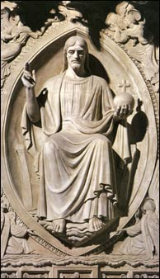  Majestus. Walker Hancock, sculptor, and Roger Morigi, carver.  From the Ter Sanctus reredos (wall behind the high altar)  at the National Cathedral, Washington, D.C.
Ministers Serving Today

Presider: The Very Rev. Kendra Wilde, Dean & Rector
Piano: Patty Dean
Acolyte: Duke Demmons
Lectors: Sharon Nielsen and Lizzie Carlson-Thompson
Eucharistic Minister (EM): Chris Boyce
Eucharistic Visitors (EV): Jennie Ekwortzel, Barb Hoag, and Manny Hoag
Ushers: Sara Medley & Sharron Moran
Prelude

Hymn, H-518 Christ is made the sure foundation Tune: Westminster Abbey

The Word of God

Opening Acclamation

Blessed be God: Father, Son, and Holy Spirit.
And blessed be his kingdom, now and for ever. Amen.

Opening Collect

Almighty God, unto whom all hearts are open, all desires known, and from whom no secrets are hid: Cleanse the thoughts of our hearts by the inspiration of thy Holy Spirit, that we may perfectly love thee, and worthily magnify thy holy Name; through Christ our Lord. Amen.

Gloria (Metrical paraphrase) Tune: Hymn to joy

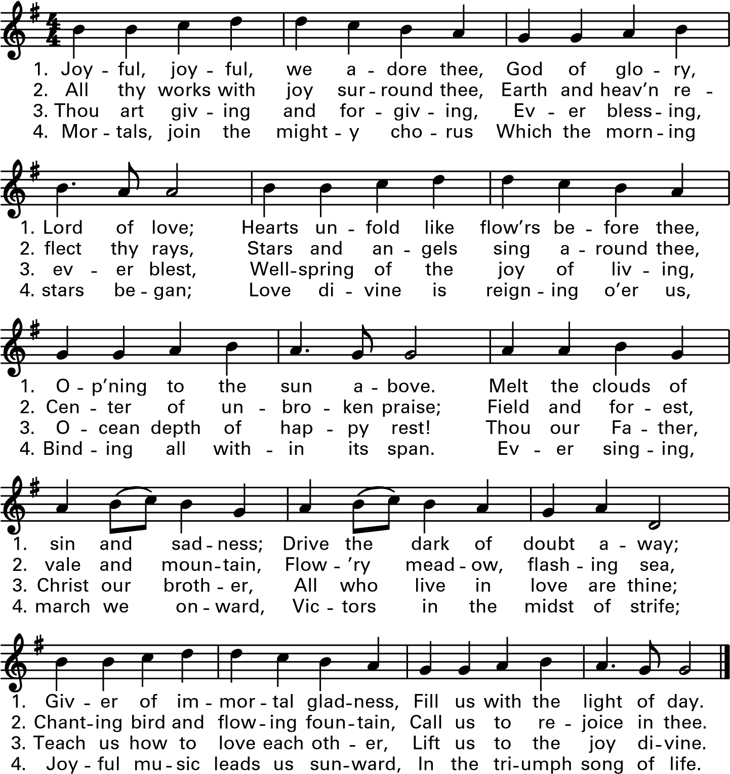

Glo - ry, praise to God the Fa - ther, Peace on earth to
Son of God, you heal our sin, Have mer - cy on us,

all this day. We a - dore, we glo - ri - fy, —
hear our plea. Seat - ed at the Fa - ther’s side, Lord

thanks we give for your new Way. Heav’n - ly Fa - ther,
Je - sus, set our spi - rits free. Heav’n- ly Fa - ther,

Lord and King, Al - might - y God, your prais - es ring!
Lord and King, Al - might - y God, your prais - es ring!

Je - sus Christ, your gift of love, you gave to earth from heav’n a - bove.
Je - sus Christ, the Son was giv’n to bring to us your love from heav’n.

The Collect of the Day

The Lord be with you.
And with thy spirit.
Let us pray.
Almighty and everlasting God, whose will it is to restore all things in thy well-beloved Son, the King of kings and Lord of lords: Mercifully grant that the peoples of the earth, divided and enslaved by sin, may be freed and brought together under his most gracious rule; who liveth and reigneth with thee and the Holy Spirit, one God, now and for ever. Amen.

Old Testament Reading Jeremiah 23:1-6

Woe to the shepherds who destroy and scatter the sheep of my pasture! says the Lord. Therefore thus says the Lord, the God of Israel, concerning the shepherds who shepherd my people: It is you who have scattered my flock, and have driven them away, and you have not attended to them. So I will attend to you for your evil doings, says the Lord. Then I myself will gather the remnant of my flock out of all the lands where I have driven them, and I will bring them back to their fold, and they shall be fruitful and multiply. I will raise up shepherds over them who will shepherd them, and they shall not fear any longer, or be dismayed, nor shall any be missing, says the Lord. The days are surely coming, says the Lord, when I will raise up for David a righteous Branch, and he shall reign as king and deal wisely, and shall execute justice and righteousness in the land. In his days Judah will be saved and Israel will live in safety. And this is the name by which he will be called: “The Lord is our righteousness.”

The Word of the Lord.
Thanks be to God.

The Response: Canticle 16: The Song of Zechariah: (Metrical paraphrase) Tune: Winchester New
2. He promised through his prophets once
To save us from our foes’ intent;
He promised to show mercy and
Recall his holy covenant.

4. And you, my child, shall now be called
The prophet to prepare his way,
To teach salvation to his own
By putting all their sins away.

1. Blesséd be Israel’s Lord and God,
For he has come and freed his own;
He sent a mighty savior born
Of David’s house and for his throne.

3. He swore this oath to Abraham,
To set us free from hostile might,
To worship him, free from all fear,
Holy and righteous in his sight.

5. In the compassion of our God
The heavenly dawn shall bring release,
To shine on those who dwell in fear
And guide us in the way of peace.

New Testament Reading Colossians 1:11-20

May you be made strong with all the strength that comes from his glorious power, and may you be prepared to endure everything with patience, while joyfully giving thanks to the Father, who has enabled you to share in the inheritance of the saints in the light. He has rescued us from the power of darkness and transferred us into the kingdom of his beloved Son, in whom we have redemption, the forgiveness of sins. He is the image of the invisible God, the firstborn of all creation; for in him all things in heaven and on earth were created, things visible and invisible, whether thrones or dominions or rulers or powers—all things have been created through him and for him. He himself is before all things, and in him all things hold together. He is the head of the body, the church; he is the beginning, the firstborn from the dead, so that he might come to have first place in everything. For in him all the fullness of God was pleased to dwell, and through him God was pleased to reconcile to himself all things, whether on earth or in heaven, by making peace through the blood of his cross.
The Word of the Lord.
Thanks be to God.

The Sequence hymn Sing, my soul, his wondrous love Tune: St. Bees

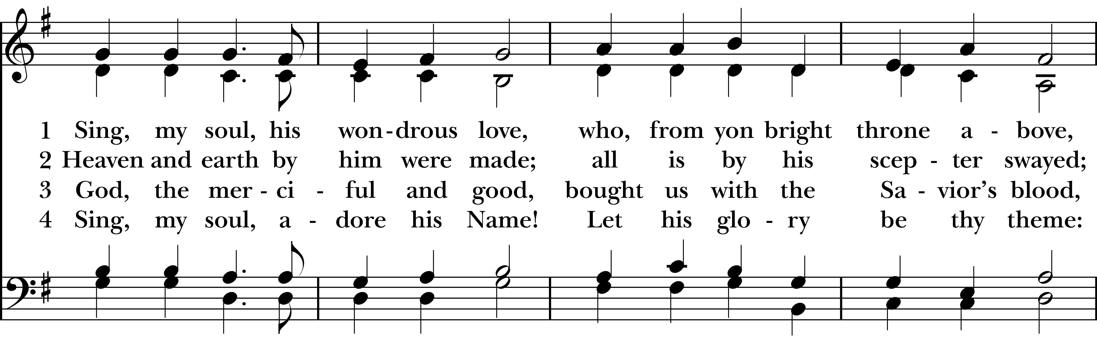
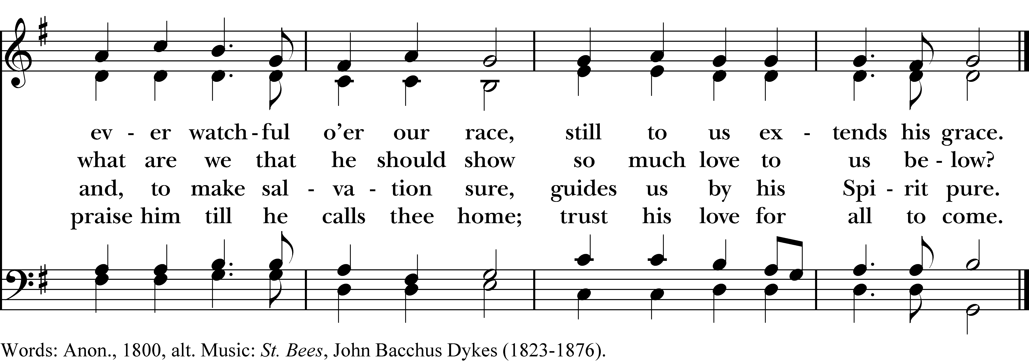

The Gospel Proclamation Luke 23:33-43

The Holy Gospel of our Lord Jesus Christ according to Luke. Glory be to thee, O Lord.

When they came to the place that is called The Skull, they crucified Jesus there with the criminals, one on his right and one on his left. Then Jesus said, “Father, forgive them; for they do not know what they are doing.” And they cast lots to divide his clothing. The people stood by, watching Jesus on the cross; but the leaders scoffed, saying, “He saved others; let him save himself if he is the Messiah of God, his chosen one!” The soldiers also mocked him, offering him sour wine, and saying, “If you are the King of the Jews, save yourself!” There was also an inscription over him, “This is the King of the Jews.” One of the criminals who were hanged there kept deriding him and saying, “Are you not the Messiah? Save yourself and us!” But the other rebuked him, saying, “Do you not fear God, since you are under the same sentence of condemnation? And we indeed have been condemned justly, for we are getting what we deserve for our deeds, but this man has done nothing wrong.” Then he said, “Jesus, remember me when you come into your kingdom.” He replied, “Truly I tell you, today you will be with me in Paradise.”

The Gospel of the Lord. Praise be to thee, O Christ.
The Sermon The Very Rev. Kendra Wilde
The Nicene Creed BCP 326
We believe in one God, the Father, the Almighty, maker of heaven and earth, of all that is, seen and unseen.

We believe in one Lord, Jesus Christ, the only Son of God, eternally begotten of the Father, God from God, Light from Light, true God from true God, begotten, not made, of one Being with the Father. Through him all things were made. For us and for our salvation he came down from heaven: by the power of the Holy Spirit he became incarnate from the Virgin Mary, and was made man. For our sake he was crucified under Pontius Pilate; he suffered death and was buried. On the third day he rose again in accordance with the Scriptures; he ascended into heaven and is seated at the right hand of the Father. He will come again in glory to judge the living and the dead, and his kingdom will have no end.

We believe in the Holy Spirit, the Lord, the giver of life, who proceeds from the Father and the Son. With the Father and the Son he is worshiped and glorified. He has spoken through the Prophets. We believe in one holy catholic and apostolic Church. We acknowledge one baptism for the forgiveness of sins. We look for the resurrection of the dead, and the life of the world to come. Amen.

The Prayers of the People

Leader In peace, we pray to thee, Lord God.

Silence

For all people in their daily life and work; guide us to reach out in friendship to those who struggle with the demands of the holiday season—invite a spirit of hospitality in us to open our homes and our lives to others, especially those who are isolated or far away from loved ones.
For our families, friends, and neighbors, and for those who are alone.

For our community, the nation, and the world;
For all who work for justice, freedom, and peace.

For the just and proper use of thy creation; as our nation prepares for a day of thanksgiving and rest, guard us against greed for material things and the carelessness of empty consuming, that we may instead strive for equitable distribution of thy gifts; guide our thoughts, hopes, and fulfillment to be centered on thy grace and on the truth proclaimed by thy Son.
For all who model humility and faithful stewardship of the planet and its resources.

For any child of God who is in danger, sorrow, or any kind of trouble, for those who are hungry, unsheltered or inadequately sheltered, especially our Family Promise siblings, for those who are unemployed, and those who are victims of fear, cruelty, and oppression.
For all who minister to those who are sick, friendless, lonely, or in need.
For the peace and unity of the Church of God; for Sarah our Archbishop of Canterbury, Sean our Presiding Bishop and Marty our Bishop; and for all bishops and other ministers;
For all who proclaim the Gospel, and all who serve in God’s Church.

For the special needs and concerns of this congregation.

The People may add their own petitions

Hear us, Lord;
For thy mercy is great.

We thank thee, O Lord, for thy blessings in this life: thy grace, hope, love, and the gift of joy and wonder in all thy works; kindle in us genuine gratitude for all the comforts that come from thy bounty and teach us to give thee praise and thanks each day.

The People may add their own thanksgivings

We will exalt thee, O God, our only King;
And praise thy Name for ever and ever.

We pray for all who have died, that they may have a place in thy eternal kingdom.

The People may add their own petitions

O Lord, let thy loving-kindness be upon them;
Who put their trust in thee.

We pray to thee also for the forgiveness of our sins.

Silence

Have mercy upon us, most merciful Father; in thy compassion forgive us our sins, known and unknown, things done and left undone; and so uphold us by thy Spirit that we may live and serve thee in newness of life, to the honor and glory of thy Name; through Jesus Christ our Lord. Amen.

The Presider concludes with an absolution or a suitable Collect.

The Peace

Announcements

Prayer for birthdays | Prayer for anniversaries
Watch over thy children, O Lord, as their days increase; bless and guide them wherever they may be. Strengthen them when they stand; comfort them when discouraged or sorrowful; raise them up if they fall; and in their hearts may thy peace which passeth understanding abide all the days of their lives; through Jesus Christ our Lord. Amen. | We thank thee, O God, for consecrating the marriage of N. and N. in Christ’s Name and presence. Lead them in companionship with each other and with you. Give them grace to live in love and fidelity. Strengthen them all their days, and bring them to that holy table where, with those we love, we will feast for ever in our heavenly home; through Christ our Lord. Amen.
The Holy Communion

The Offertory sentence

Offertory Hymn, H-460 (Omit stanza 2) Alleluia! Sing to Jesus Tune: Hyfrydol

The Great Thanksgiving

The Lord be with you.
And with thy spirit.
Lift up your hearts.
We lift them to the Lord.
Let us give thanks to the Lord our God.
It is meet and right so to do.

It is very meet, right, and our bounden duty, that we should at all times, and in all places, give thanks unto thee, O Lord, holy Father, almighty, everlasting God, through Jesus Christ our Lord; who on the first day of the week overcame death and the grave, and by his glorious resurrection opened to us the way of everlasting life. Therefore with Angels and Archangels, and with all the company of heaven, we laud and magnify thy glorious Name; evermore praising thee, and saying,

Holy, holy, holy, Lord God of Hosts:
Heaven and earth are full of thy glory.
Glory be to thee, O Lord Most High.
Blessed is he that cometh in the name of the Lord.
Hosanna in the highest.

We give thanks to thee, O God, for the goodness and love which thou hast made known to us in creation; in the calling of Israel to be thy people; in thy Word spoken through the prophets; and above all in the Word made flesh, Jesus, thy Son. For in these last days thou didst send him to be incarnate from the Virgin Mary, to be the Savior and Redeemer of the world. In him, thou hast delivered us from evil, and made us worthy to stand before thee. In him, thou hast brought us out of error into truth, out of sin into righteousness, out of death into life.

On the night before he died for us, our Lord Jesus Christ took bread; and when he had given thanks, he broke it, and gave it to his disciples, and said, “Take, eat: This is my Body, which is given for you. Do this for the remembrance of me.” After supper he took the cup of wine; and when he had given thanks, he gave it to them, and said, “Drink this, all of you: This is my Blood of the new Covenant, which is shed for you and for many for the forgiveness of sins. Whenever you drink it, do this for the remembrance of me.” Therefore, according to his command, O Father,

We remember his death,
we proclaim his resurrection,
we await his coming in glory;

And we offer our sacrifice of praise and thanksgiving to thee, O Lord of all; presenting to thee, from thy creation, this bread and this wine. We pray thee, gracious God, to send thy Holy Spirit upon these gifts that they may be the Sacrament of the Body of Christ and his Blood of the new Covenant. Unite us to thy Son in his sacrifice, that we may be acceptable through him, being sanctified by thy Holy Spirit.

In the fullness of time, put all things in subjection under thy Christ, and bring us to that heavenly country where, with all thy saints, we may enter the everlasting heritage of thy sons and daughters; through Jesus Christ our Lord, the firstborn of all creation, the head of the Church, and the author of our salvation, by whom, and with whom, and in whom, in the unity of the Holy Ghost all honor and glory be unto thee, O Father Almighty, world without end. AMEN.

And now, as our Savior Christ has taught us, we are bold to say,

Our Father, who art in heaven, hallowed be thy Name, thy kingdom come, thy will be done, on earth as it is in heaven. Give us this day our daily bread. And forgive us our trespasses, as we forgive those who trespass against us. And lead us not into temptation, but deliver us from evil. For thine is the kingdom, and the power, and the glory, for ever and ever. Amen.

The Breaking of the Bread

Silence

Alleluia. Christ our Passover is sacrificed for us.
Therefore let us keep the feast. Alleluia.

The holy gifts of God for the holy people of God.

The Prayer for Spiritual Communion on behalf of those participating remotely

Christ welcomes all to communion at his banquet table. ■ Receive the bread in the nest of your outstretched hands, and sip the wine, guiding the chalice to your lips. ■ If you do not want to sip the wine, it is also perfectly appropriate to receive the bread alone. ■ You may respond to communion by saying “Amen.” ■ Tell the minister if you require gluten-free elements. ■ Instead of the bread and wine, if you prefer a blessing, cross your hands over your chest. ■ In the Episcopal Church Baptism generally precedes receiving the bread and wine of communion and is offered several times a year; please speak to a member of the clergy to learn more. ■

Music at Communion

Piano Interlude

Hymn, H-324 Let all mortal flesh keep silence Tune: Picardy
Hymn, H-708 Savior, like a Shepherd lead us Tune: Sicilian Mariners
Post Communion Prayer

Let us pray.

Almighty and everliving God, we most heartily thank thee for that thou dost feed us, in these holy mysteries, with the spiritual food of the most precious Body and Blood of thy Son our Savior Jesus Christ; and dost assure us thereby of thy favor and goodness towards us; and that we are very members incorporate in the mystical body of thy Son, the blessed company of all faithful people; and are also heirs, through hope, of thy everlasting kingdom. And we humbly beseech thee, O heavenly Father, so to assist us with thy grace, that we may continue in that holy fellowship, and do all such good works as thou hast prepared for us to walk in; through Jesus Christ our Lord, to whom, with thee and the Holy Ghost, be all honor and glory, world without end. Amen.

Sending Forth of Eucharistic Ministers

In the name of Christ and this congregation, we send forth Jennie, Barb, and Manny bearing these holy gifts, that Sarah McHugh may share with us in the communion of Christ’s body and blood.
We who are many are one body, for we all share one bread, one cup.

The Children’s Moment The Very Rev. Kendra Wilde

The Blessing

Hymn, H-494 Crown him with many crowns Tune: Diademata

The Dismissal

Postlude

Next Week’s Liturgical Ministers

Piano: Patty Dean
Acolyte: Zora Robison
Eucharistic Minister (EM): Lizzie Carlson-Thompson
Lectors: TBA
Ushers: Sam Gilbert & Donna Lloyd

Please note:
Photography and video recording may be in process while you are at the Cathedral.
Entry into the facility signifies your release and consent to the possibility
that your image may be used by the Cathedral for promotional purposes.

Liturgical note: Christ the King Sunday is 100 years old this year!

Today we celebrate “Christ the King” Sunday, signaling the culmination of the year in Christian churches around the world. As we do each Sunday, we proclaim Christ as “God from God, Light from Light, true God from true God”—the sole sovereign of the universe—whose reign we await in its fullness at the end of time. But today is special.

This year marks the 100th celebration of “Christ the King” Sunday, after its establishment by Pope Pius XI, as a feast day for Roman Catholics. It didn’t take long for its observance to spread to other Christian traditions as its message was so timely.

In 1925, when the pope instituted this feast day, the world was still reeling from the twin tragedies of a world war and an influenza pandemic in the decade prior. In its wake, a new and uncertain world was rising as people were drawn to bow down before “lords” of exploitative consumerism, rising nationalism, growing secularism, and a shift to urbanization and industrialization.

In the struggle for political power after WWI, fascism was on the rise worldwide and, notably for the pope, in 1925, Italy’s Benito Mussolini proclaimed himself dictator and supreme leader (“Il Duce”), and began suppressing citizens’ rights and freedoms. The Pope responded by instituting a day to remind Christians that we have only one king to whom we give our deepest loyalty; his name is Jesus—and he alone is “Lord of lords” and “King of all” as we sing in today’s closing hymn. In the encyclical he issued establishing this day, Pope Pius wrote that he envisioned “a dominion by a King of Peace who came to reconcile all things, who came not to be served but to serve.” Under Christ’s Lordship, we are heirs of God’s Kingdom, with all the Communion of Saints—in service.

And that is something to celebrate! Happy Christ the King Sunday!

Copyrighted Materials: Unless otherwise noted, music is reproduced and/or broadcast under OneLicense.net A-727892. Some hymn permissions are by Rite Song a one-time use reprint license for congregational use. ♱ Opening hymn: Christ is made the sure foundation. Words: Latin, ca. 7th cent.; tr. Hymns Ancient and Modern, 1861, after John Mason Neale (1818-1866), alt. Music: Westminster Abbey, Henry Purcell (1659-1695), adapt.; desc. James Gillespie (1929 - 2015), Hymnal 1982, © Church Hymnal Corp., 1985. ♱ Gloria: Music: Hymn to joy, Ludwig van Beethoven (1770-1827); ♱ Response: Canticle 16, The Song of Zechariah, para. of The First Song of Isaiah. Music: Winchester New, melody from Musicalishes Hand-Buch,1690; The New Metrical Psalter, Christopher L. Webber (1953), Church Hymnal Corp., 1986. ♱ Sequence hymn: Sing, my soul, his wondrous love. Words: Anon., 1800, alt. Music: St. Bees, John Bacchus Dykes (1823-1876), Hymnal 1982, © Church Hymnal Corp., 1985. ♱ Offertory hymn: Alleluia! Sing to Jesus! Words: William Chatterton Dix (1837-1898) Music: Hyfrydol, Rowland Hugh Prichard (1811-1887), Hymnal 1982, © Church Hymnal Corp., 1985. ♱ Communion hymns: Let all mortal flesh keep silence. Words: Liturgy of St. James; para. Gerard Moultrie (1829-1885). Music: Picardy, French carol, 17th cent.; melody from Chansons populaires des Provinces de France, 1860; and Savior like a shepherd lead us, Words: Hymns for the Young, ca. 1830, alt. Music: Sicilian Mariners, Sicilian melody, from The European Magazine and London Review, 1792, both from Hymnal 1982, © Church Hymnal Corp., 1985. ♱ Closing Hymn: Crown him with many crowns. Words: Matthew Bridges (1800-1894). Music: Diademata, George Job Elvey (1816-1893); desc. Richard Proulx (1937-2010); Hymnal 1982, © Church Hymnal Corp., 1985 ♱ Liturgical texts: Except as noted, The Book of Common Prayer (rendered in traditional language) © Church Pension Fund. Reprinted by permission. The form for Prayers of the People is from the Book of Common Prayer, adapted for this occasion. ♱ Anniversary blessing, Book of Occasional Services, Church Publishing, 2022. ♱ Old Testament, New Testament and Gospel Lessons: From The New Revised Standard Version Bible © 1989, the Division of Christian Education of the National Council of the Churches of Christ in the USA. Used by permission. ♱ EV Sending, Enriching Our Worship, Vol. 2, Church Publishing, Inc., 2000. ♱

