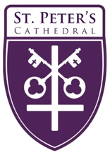
The Rt. Rev. Marty Stebbins, Bishop
The Very Rev. Kendra Wilde, Dean

The Holy Eucharist
The Twenty-second Sunday after Pentecost
November 9, 2025, 9:00 am & Livestreamed Online

Welcome to St. Peter’s Cathedral!

We’re delighted you’re here. Whether you’ve been here for years or it’s your first time with us, we hope you’ll find richness in offering your prayers and praise with us during worship. And afterward, please join us downstairs for snacks. Whoever you are and wherever you come from, wherever you hurt today, whatever you bring today, you are welcome at Christ’s table and here at St. Peter’s.

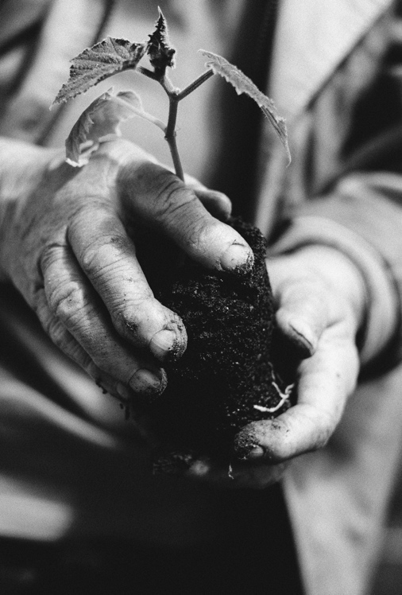
Photo: Tamara Elnova
Ministers Serving Today

Presider: The Very Rev. Kendra Wilde
Piano: Patty Dean
Acolyte: Annalee Curtis
Lectors: Patty Dean & Matt Jaynes
Eucharistic Minister (EM): Hope Stockwell
Eucharistic Visitors (EV): Donna Church & Chris Boyce
Barb & Manny Hoag,
Maggie Stockwell
Ushers: Marsha Baumeister & Cathy Morris

We draw our liturgy from a variety of approved resources.
Please see endnotes for sources and permissions.

The People’s responses
are printed in boldface.

Please silence
electronic devices

Prelude

Hymn, H-372 Praise to the Living God Tune: Leoni

The Word of God

The Opening Acclamation

Blessed be God: Father, Son, and Holy Spirit.
And blessed be his kingdom, now and for ever. Amen.

The Opening Collect

Almighty God, to you all hearts are open, all desires known, and from you no secrets are hid: Cleanse the thoughts of our hearts by the inspiration of your Holy Spirit, that we may perfectly love you, and worthily magnify your holy Name; through Christ our Lord. Amen.

The Gloria Jaques Berthier (1923-1994)
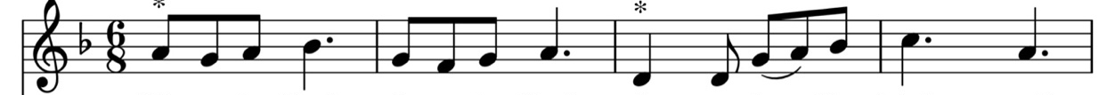

Glo - ri - a! Glo - ri - a! In ex - cel - sis De - o.

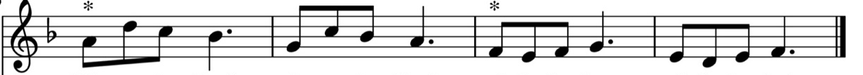

Glo - ri - a! Glo - ri - a! Al - le - lu- ia! Al - le - lu- ia!

The Collect of the Day

The Lord be with you.
And also with you.
Let us pray.

O God, whose blessed Son came into the world that he might destroy the works of the devil and make us children of God and heirs of eternal life: Grant that, having this hope, we may purify ourselves as he is pure; that, when he comes again with power and great glory, we may be made like him in his eternal and glorious kingdom; where he lives and reigns with you and the Holy Spirit, one God, for ever and ever. Amen.

The Old Testament Reading Haggai 1:15b – 2:9

In the second year of King Darius, in the seventh month, on the twenty-first day of the month, the word of the Lord came by the prophet Haggai, saying: Speak now to Zerubbabel son of Shealtiel, governor of Judah, and to Joshua son of Jehozadak, the high priest, and to the remnant of the people, and say, Who is left among you that saw this house in its former glory? How does it look to you now? Is it not in your sight as nothing? Yet now take courage, O Zerubbabel, says the Lord; take courage, O Joshua, son of Jehozadak, the high priest; take courage, all you people of the land, says the Lord; work, for I am with you, says the Lord of hosts, according to the promise that I made you when you came out of Egypt. My spirit abides among you; do not fear. For thus says the Lord of hosts: Once again, in a little while, I will shake the heavens and the earth and the sea and the dry land; and I will shake all the nations, so that the treasure of all nations shall come, and I will fill this house with splendor, says the Lord of hosts. The silver is mine, and the gold is mine, says the Lord of hosts. The latter splendor of this house shall be greater than the former, says the Lord of hosts; and in this place I will give prosperity, says the Lord of hosts.

The Word of the Lord.
Thanks be to God.

The Response: Psalm 98: (Metrical paraphrase) Tune: Azmon

2. The victory the Lord has won
He has this day made known;
To all the world his righteousness
Has openly been shown.

4. All nations, shout with joy to God
Lift up your voice and sing;
Sing to the Lord now with the harp;
Let heart and voices ring.

6. Let hills ring out with joy to God,
Let rivers clap their hands;
In righteousness shall all be judged,
In equity, all lands.

1. Sing to the Lord new songs, proclaim
The marvels he has done
With his right hand and holy arm,
The triumph he has won.

3. The Lord recalls for Israel
His love and faithfulness;
To all the earth his victory
Has been made manifest.

5. With trumpets and the sound of horns
Rejoice before the Lord;
From all who dwell on land and sea
Let praises be outpoured

The New Testament 2 Thessalonians 2:5 – 3:17

As to the coming of our Lord Jesus Christ and our being gathered together to him, we beg you, brothers and sisters, not to be quickly shaken in mind or alarmed, either by spirit or by word or by letter, as though from us, to the effect that the day of the Lord is already here. Let no one deceive you in any way; for that day will not come unless the rebellion comes first and the lawless one is revealed, the one destined for destruction. He opposes and exalts himself above every so-called god or object of worship, so that he takes his seat in the temple of God, declaring himself to be God. Do you not remember that I told you these things when I was still with you?

But we must always give thanks to God for you, brothers and sisters beloved by the Lord, because God chose you as the first fruits for salvation through sanctification by the Spirit and through belief in the truth. For this purpose he called you through our proclamation of the good news, so that you may obtain the glory of our Lord Jesus Christ. So then, brothers and sisters, stand firm and hold fast to the traditions that you were taught by us, either by word of mouth or by our letter. Now may our Lord Jesus Christ himself and God our Father, who loved us and through grace gave us eternal comfort and good hope, comfort your hearts and strengthen them in every good work and word.

The Word of the Lord.
Thanks be to God.
The Sequence hymn Sing Praise to our creator Tune: Christus, der ist mein Leben

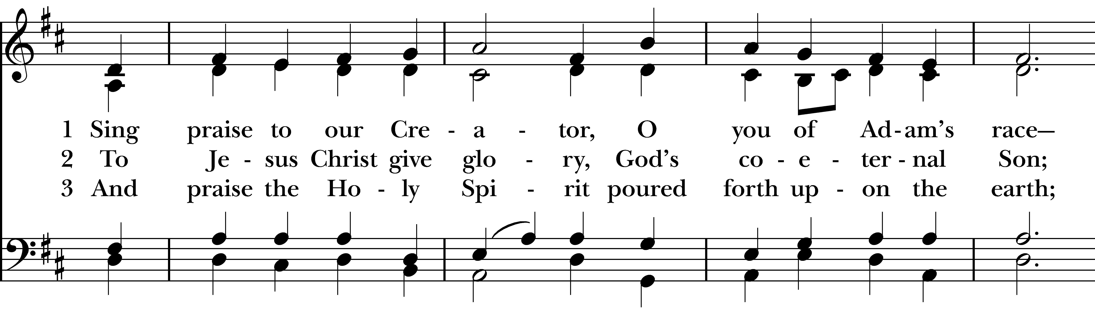
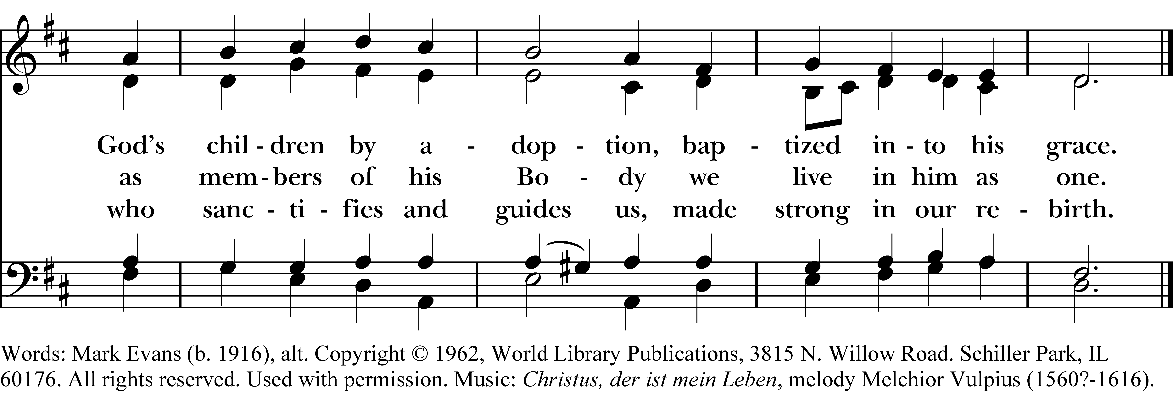

The Gospel Proclamation Luke 20:27-38

The Holy Gospel of our Lord Jesus Christ according to Luke.
Glory to you, Lord Christ.

Some Sadducees, those who say there is no resurrection, came to Jesus and asked him a question, “Teacher, Moses wrote for us that if a man’s brother dies, leaving a wife but no children, the man shall marry the widow and raise up children for his brother. Now there were seven brothers; the first married, and died childless; then the second and the third married her, and so in the same way all seven died childless. Finally the woman also died. In the resurrection, therefore, whose wife will the woman be? For the seven had married her.”

Jesus said to them, “Those who belong to this age marry and are given in marriage; but those who are considered worthy of a place in that age and in the resurrection from the dead neither marry nor are given in marriage. Indeed they cannot die anymore, because they are like angels and are children of God, being children of the resurrection. And the fact that the dead are raised Moses himself showed, in the story about the bush, where he speaks of the Lord as the God of Abraham, the God of Isaac, and the God of Jacob. Now he is God not of the dead, but of the living; for to him all of them are alive.”

The Gospel of the Lord.
Praise to you, Lord Christ.

The Sermon The Very Rev. Kendra Wilde
The Nicene Creed BCP 358
We believe in one God, the Father, the Almighty, maker of heaven and earth, of all that is, seen and unseen.

We believe in one Lord, Jesus Christ, the only Son of God, eternally begotten of the Father, God from God, Light from Light, true God from true God, begotten, not made, of one Being with the Father. Through him all things were made. For us and for our salvation he came down from heaven: by the power of the Holy Spirit he became incarnate from the Virgin Mary, and was made man. For our sake he was crucified under Pontius Pilate; he suffered death and was buried. On the third day he rose again in accordance with the Scriptures; he ascended into heaven and is seated at the right hand of the Father. He will come again in glory to judge the living and the dead, and his kingdom will have no end.

We believe in the Holy Spirit, the Lord, the giver of life, who proceeds from the Father and the Son. With the Father and the Son he is worshiped and glorified. He has spoken through the Prophets. We believe in one holy catholic and apostolic Church. We acknowledge one baptism for the forgiveness of sins. We look for the resurrection of the dead, and the life of the world to come. Amen.

The Prayers of the People

Leader In peace, we pray to you, Lord God.

Silence

For all people in their daily life and work;
For our families, friends, and neighbors, and for those who are alone.

For our community, the nation, and the world; for military veterans and all who serve our nation at home or abroad, in times of conflict and in times of tranquility. We pray also for those recently elected to public office, that they may carry out your will in service to the common good.
For all who work for justice, freedom, and peace.

For a just and proper relationship with our planet and with all whom you have created, remembering especially those who are hungry, unsheltered or inadequately sheltered, those who are unemployed, and those suffering from natural disasters, especially Hurricane Melissa.
For all who offer relief, respite, shelter, and other acts of human kindness.

For any child of God who lives with violence, danger, sorrow, or any kind of trouble,
For all who minister to those who are sick, friendless, lonely, or in need.

For the peace and unity of the Church of God;
For all who proclaim the Gospel, and all who seek God’s Truth.

For Sean our Presiding Bishop and Marty our Bishop; and for all bishops and other ministers;
For all who serve in God’s Church.

For the special needs and concerns of this congregation.

The People may add their own petitions

Hear us, Lord;
For your mercy is great.

We thank you, Lord, for all the blessings of this life. And we offer thanksgiving for all hunger relief agencies, including Amy’s Mess, God’s Love, Helena Food Share, Meals on Wheels, and Rocky Mountain Development Council.
The Church: for Sean, our Presiding Bishop; for Marty, our Bishop; for Kendra, our Dean; for the Togendowagan Society, Darcy and Dan, their Elders; and for St. James’, Dillon, Rector, Theresa Kelley Bergmann.
The Government: for Donald, our President; for Greg, our Governor; for Congress, especially Tim, Steve, Ryan and Troy. Also, for Kelly, Vickie, and Wilmot, our area mayors.
The Community: for the staff, volunteers, and beneficiaries of God’s Love, Good Samaritan Ministries, Family Promise, Helena Food Share, Friendship Center, Head Start, and YWCA.
Comfort, Healing & Hope: for Kevin, Ray, Kathy J., Dick, Bob D, Gene, Janet, Sarah, the family of Joseph Passamani, grieving his passing.
Those Serving in our Armed Forces: for David Emineth, Shane Medley, Charles Lewis, Kenneth V Liston, and Parker Jones.

The People may add their own thanksgivings

We will exalt you, O God our only King;
And praise your Name for ever and ever.

We pray for all who have died, that they may have a place in your eternal kingdom.

The People may add their own petitions

Lord, let your loving-kindness be upon them;
Who put their trust in you.

We pray to you also for the forgiveness of our sins.

Silence

Have mercy upon us, most merciful Father; in your compassion forgive us our sins, known and unknown, things done and left undone; and so uphold us by your Spirit that we may live and serve you in newness of life, to the honor and glory of your Name; through Jesus Christ our Lord. Amen.

The Celebrant concludes with an absolution or a suitable Collect

The Peace

The Announcements

The Prayer for birthdays BCP 830

Watch over your children, O Lord, as their days increase; bless and guide them wherever they may be. Strengthen them when they stand; comfort them when discouraged or sorrowful; raise them up if they fall; and in their hearts may your peace which passes understanding abide all the days of their lives; through Jesus Christ our Lord. Amen.

The Prayer for anniversaries

We thank you, most gracious God, for consecrating the marriage of N. and N. in Christ’s Name and presence. Lead them further in companionship with each other and with you. Give them grace to live together in love and fidelity, with care for one another. Strengthen them all their days, and bring them to that holy table where, with those we love, we will feast for ever in our heavenly home; through Jesus Christ our Lord. Amen.
The Holy Communion

The Offertory sentence

The Offertory Hymn, H-525 The Church’s one foundation Tune: Aurelia

The Great Thanksgiving

The Lord be with you.
And also with you.
Lift up your hearts.
We lift them to the Lord.
Let us give thanks to the Lord our God.
It is right to give our thanks and praise.

It is right, and a good and joyful thing, always and everywhere to give thanks to you, Father Almighty, Creator of heaven and earth. For by water and the Holy Spirit you have made us a new people in Jesus Christ our Lord, to show forth your glory in all the world.

We praise you and we bless you, holy and gracious God, source of life abundant. From before time you made ready the creation. Your Spirit moved over the deep and brought all things into being: sun, moon, and stars; earth, winds, and waters; and every living thing. You made us in your image, and taught us to walk in your ways. But we rebelled against you, and wandered far away; and yet, as a mother cares for her children, you would not forget us. Time and again you called us to live in the fullness of your love. And so this day we join with Saints and Angels in the chorus of praise that rings through eternity, lifting our voices to magnify you as we sing:

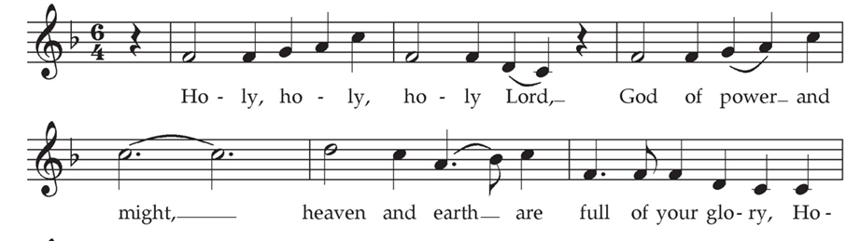

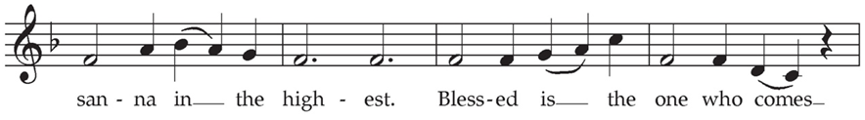
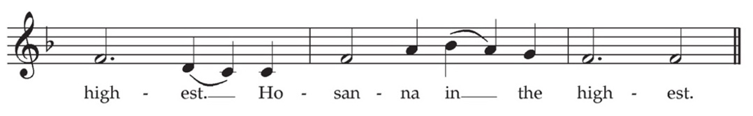
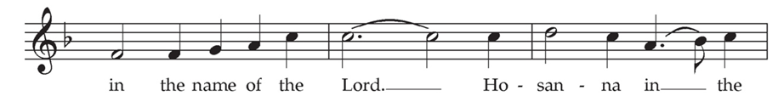

Glory and honor and praise to you, holy and living God. To deliver us from the power of sin and death and to reveal the riches of your grace, you looked with favor upon Mary, your willing servant, that she might conceive and bear a son, Jesus the holy child of God. Living among us, Jesus loved us. He broke bread with outcasts and sinners, healed the sick, and proclaimed good news to the poor. He yearned to draw all the world to himself yet we were heedless of his call to walk in love. Then, the time came for him to complete upon the cross the sacrifice of his life, and to be glorified by you.

On the night before he died for us, our Lord Jesus Christ took bread; and when he had given thanks to you, he broke it, and gave it to his disciples, and said, “Take, eat: This is my Body, which is given for you. Do this for the remembrance of me.” After supper he took the cup of wine; and when he had given thanks, he gave it to them, and said, “Drink this, all of you: This is my Blood of the new Covenant, which is shed for you and for all for the forgiveness of sins. Whenever you drink it, do this for the remembrance of me.” Now gathered at your table, O God of all creation, and remembering Christ, God-with-us, crucified and risen, who was and is and is to come, we offer to you our gifts of bread and wine, and ourselves, a living sacrifice. Pour out your Spirit upon these gifts that they may be the Body and Blood of Christ. Breathe your Spirit over the whole earth and make us your new creation, the Body of Christ given for the world you have made. In the fullness of time bring us, with all your saints, from every tribe and language and people and nation, to feast at the banquet prepared from the foundation of the world. Through Christ and with Christ and in Christ, in the unity of the Holy Spirit, to you be honor, glory, and praise, for ever and ever. AMEN.

And now, as our Savior Christ has taught us, we are bold to say,

Our Father, who art in heaven, hallowed be thy Name, thy kingdom come, thy will be done, on earth as it is in heaven. Give us this day our daily bread. And forgive us our trespasses, as we forgive those who trespass against us. And lead us not into temptation, but deliver us from evil. For thine is the kingdom, and the power, and the glory, for ever and ever. Amen.

The Breaking of the Bread

Silence

Alleluia. Christ our Passover is sacrificed for us.
Therefore let us keep the feast. Alleluia.

The holy gifts of God for the holy people of God.

Christ welcomes all to communion. ■ Receive the bread in open and outstretched hands and sip the wine, guiding the chalice to your lips. ■ If you do not want to sip the wine, it is also perfectly appropriate to receive the bread only. ■ You may respond to communion by saying “Amen.” ■ If you prefer a blessing, cross your hands over your chest. ■ Tell the minister if you require gluten-free elements. ■ In the Episcopal Church Baptism generally precedes communion and is offered several times a year; please speak to a member of the clergy to learn more. ■

The Prayer for Spiritual Communion on behalf of those participating remotely

Music at Communion

Piano Interlude

Hymn, H-574 Before thy throne, O God, we kneel Tune: St. Petersburg
Hymn, H-341 For the bread which you have broken Tune: Omni Dei

Post Communion Prayer

Let us pray. God of abundance, you have fed us with the bread of life and cup of salvation; you have united us with Christ and one another; and you have made us one with all your people in heaven and on earth. Now send us forth in the power of your Spirit, that we may proclaim your redeeming love to the world and continue for ever in the risen life of Christ our Savior. Amen.

Sending Forth of Eucharistic Ministers

In the name of Christ and this congregation, we send forth Donna, Chris, Barb, Manny, and Maggie bearing these holy gifts, that Charlotte Eskildsen and Peggy Kude may share with us in the communion of Christ’s body and blood.
We who are many are one body, for we all share one bread, one cup.

The Children’s Moment The Very Rev. Kendra Wilde

The Blessing

Hymn, H-390 Praise to the Lord, the Almighty Tune: Lobe den Herren

The Dismissal
Go in peace to love and serve the Lord. Thanks be to God.

Postlude

Copyrighted Materials: All rights reserved. Unless otherwise noted, music is reproduced and/or broadcast under OneLicense.net A-727892. Hymn permissions are by Rite Song a one-time use reprint license for congregational use. ♱ Opening Hymn: Praise to the living God! Words: Medieval Jewish liturgy; tr. Max Landsberg (1845-1928) and Newton M. Mann (1836-1926). Music: Leoni, Hebrew melody; harm. Hymns Ancient and Modern, 1875, alt. Sequence hymn: Sing praise to our creator. Words: Mark Evans (1916-1997), alt. Copyright ©1952, World Library Publications. Music: Christus, der ist mein Leben, melody Melchior Vulpius (1560?-1616); Offertory Hymn: The Church’s one foundation. Words: Samuel John Stone (1839-1900); Music: Aurelia, Samuel Sebastian Wesley (1810-1876). Communion hymns: Before thy throne, O God, we kneel. Words: William Boyd Carpenter (1841-1918), alt. Music: St. Petersburg, Dimitri S. Bortniansky (1751-1825) and For the bread which you have broken. Words: Louis F. Benson (1855-1930), alt. Music: Omni die, melody from Gross Catolisch Gesangbuch, 1631. Closing Hymn: Praise to the Lord, the Almighty. Words: Joachim Neander (1650-1680); tr. Hymnal 1940, alt. Music: Lobe den Herren, melody from Erneuerten Gesangbuch, 1665; harm. The Chorale Book for England, 1863; desc. Craig Sellar Lange (1891-1971), all from Hymnal 1982, © Church Hymnal Corp., 1985. ♱ Gloria Tune: Jacques Berthier, © 1979, 1988, Les Presses de Taize, GIA Pub., agent; Sanctus and Benedictus: Tune: Land of Rest, adapt. Marcia Pruner, © 1980, Church Pension Fund; acc. by Richard Proulx © 1986, GIA Publications, Inc.; all from Gather 2nd ed., GIA Pub. © 1994. ♱ Liturgical texts: Except as noted, are from The Book of Common Prayer © Church Pension Fund. Reprinted by permission ♱ Anniversary blessing, Book of Occasional Services, Church Publishing, 2022. ♱ Psalm: A New Metrical Psalter, Christopher L. Webber, Church Hymnal Corporation, 1986. Used by permission in worship. Tune: Azmon. Carl Gotthilf Glaser (1784-1829); adapt. and arr. Lowell Mason (1792-1872). ♱ Old Testament, New Testament and Gospel Lessons: From The New Revised Standard Version Bible © 1989, the Division of Christian Education of the National Council of the Churches of Christ in the USA. Used by permission. ♱ Great Thanksgiving, Post-communion Prayer, and Eucharistic Visitor Sending, Enriching Our Worship, Vol. 1 (1998) and Vol. 2, (EV sending only) (2000), Church Publishing, Inc.

Please note: Photography and video recording may be in process while you are at the Cathedral. Entry into the facility signifies your release and consent to the possibility that your image may be used by the Cathedral for promotional purposes.

Next Week’s Liturgical Ministers

Piano: Patty Dean Acolyte: Abe Loveland & Eliza Loveland
Eucharistic Minister (EM): Charlie Briggs Lectors: Scott Hibbard & Ruth Ann Schuler
Ushers: Grace Berger & Mark Kelly
Eucharistic Visitors (EVs): Donna Church, Dan Carlson-Thompson, Lizzie Carlson-Thompson, Robin Erickson, and Maggie Stockwell

Liturgical Note

Some of you noted to us that as the Season after Pentecost unfolds, we’ve used varying texts in The Great Thanksgiving (aka the Eucharistic Prayer). This is the prayer the priest offers aloud at the altar—on behalf of all—after our gifts of bread, wine, and money are brought forward. Together during this prayer, we consecrate bread and wine; and after it, together, we receive Christ’s body and blood.
The 1979 Book of Common Prayer (BCP) provides six Eucharistic Prayers, each with a somewhat different focus, so that as we move through the church year we also shift emphasis on varying aspects of the mystery of God. Some prayers are almost direct descendants of the original prayer in the Church of England’s (our Mother Church’s) first BCP (1549); one has roots in an even more ancient tradition (Prayer D); and one was drafted anew (Prayer C) for the 1979 BCP. Some examples:
- Eucharistic Prayer A (BCP, 361) focuses on the mystery of the cross and resurrection, so is used in Lent and Easter and on some Sundays during the “green seasons,” the seasons after The Epiphany and after Pentecost (when the changing liturgical color is green). We’re in the Season after Pentecost now, and you have participated in this prayer several times recently;
- Eucharistic Prayer B (BCP, 367), has a focus on the mystery of the Incarnation, making it particularly apt for Advent and Christmas, and again, sometimes in the “green seasons”; depending on Sunday’s scriptural and preaching focus. We have used this prayer recently, too.
- Eucharistic Prayers 1 and 2 (BCP, 333 and 340) focus on Our Lord’s suffering and on human sinfulness, an emphasis that reflects the medieval Eucharistic theology of the Roman Church—from which Anglicanism was born.
The Episcopal Church also provides Eucharistic Prayers in the first volume of its Enriching Our Worship (EOW) series. This series, which began publication in the 1990s, is offered to broaden and deepen our worship experience. It reflects the church’s reclaiming of its grounding in ancient theology and common worship, and name our understanding of the Church as a people redeemed and reborn in Christ; a people who dwell on a planet enlivened by the diverse mysteries of God’s good creation. To expand our vocabulary of prayer, the EOW liturgies also recover ancient biblical and early-church images of the Triune God, to remind us that the mystery of God transcends all categories of knowing.
As we approach the culmination of the Season after Pentecost with “Christ the King” Sunday (November 23), St. Peter’s has incorporated into our liturgical mix Eucharistic Prayer 2 from EOW1 (p. 60) (EOW1 is available free online by searching “enriching our worship vol 1 pdf.”) Prayer 2’s language is especially suitable for Baptism (we’ve celebrated four recently!) with its reminder that in Christ we are a new creation. And in the lead-up to “Christ the King” Sunday, this prayer’s breadth of imagery recalls the incomprehensible mystery of God-in-Christ at work “over the whole earth” and among “every tribe and language and people and nation” (62). We used this prayer today!
The Episcopal Church has opted not to publish a new single-volume BCP (1500+ pages!). So, the liturgies in the EOW series have instead been incorporated into our official definition of the Book of Common Prayer. Over the past decade, our elected General Convention deputies: Lay persons, Deacons, Priests—and Bishops of the Church have conducted hundreds of churchwide public hearings and educational offerings. These culminated in the EOW texts’ authorization for the same broad use as is enjoyed by the Book of Common Prayer texts. EOW is now, officially, defined as a part of the BCP.
We hope this helps put these “new” texts into a larger context. As always—ask your clergy questions! We love them! And—good news—beginning after the holidays, after worship once a month we’ll have time together just for listening and learning about the cathedral’s—and the Episcopal Church’s— liturgies and worship. We hope you’ll be a part of these conversations.
