FAQs re: Capital Campaign November 8, 2022

How were the projects for the next hundred years chosen?
The priorities were determined by the Capital Needs Committee along with
Crossman Whitney Griffin PC (CWG architects) and accepted by the Chapter.
A formal Facilities Assessment and Master Planning Study was completed June 11, 2021
by CWG architects and is available to view if requested.

How much use will an elevator get? Is the church required to do this?
The Church is not required to put in an elevator however in order to continue to be a welcoming, accessible community an elevator was deemed a priority by the Capital Needs Committee and Chapter approved.

What will the elevator look like?
A general description for the elevator and other accessibility features was provided by CWG architects Facilities Assessment and Master Planning Study June 11, 2021:

DESIGN AND ELEVATOR TYPE: For the sake of this study, we are working with TK Elevator. https://www.tkelevator.com/ If needed we can always look at the other major elevator manufacturers, namely Otis or Kone. One of the other major considerations in picking an elevator manufacturer and model is the customer support and service as well as finding a unit that will fit most efficiently in the existing space. We have a preliminary model and design which will facilitate the need to freely move people from the main sanctuary space on the ground level to the lower basement level. We have attempted to balance budget and functionality with meeting the needs of the church without over designing or over sizing the elevator. This will be a hydraulic elevator with a “roomless” machine area. TK Endura 21 A with a 2,100- pound capacity. This elevator model will require a pit to put the power unit and equipment in as well as a hoist area above the elevator.

How will it change the appearance of the church? Where would the elevator be located and how was it determined
CONSIDERATION FOR LOCATION: We have included the as-built plans which show the existing conditions and locations of the spaces and rooms within the church. There are a number of factors which enter into the decision-making process for best possible location. • Minimize disruption to the existing interior spaces • Minimize expense in demolition and remodel costs • Minimize time in installation • Ease and convenience for end users • Functionality with other activities within the church • Minimal or no remediation work needed on the exterior of the building • Maintain historical significance of existing building • Create a clear and safe pathway for accessibility.
The current plan has the elevator inside the room just outside the nursery next to the bathroom. Above is a closet in the guild room and below is a closet next to basement choir room. Access to the elevator on the upper level would be in or near the storage closet in the Guild room. The lower-level access would be just outside the existing choir room. The architects recommended this area as the most functional and practical.

Why are we raising money for the roof if it is completed?
  - What will it cost?
  - What is the timeline?
  - Why were slate shingles used instead of a cheaper alternative?

A roof report was completed at the end of 2021 with the help of CWG and CRCL LLC to evaluate and make recommendations related to the roof of the Cathedral.
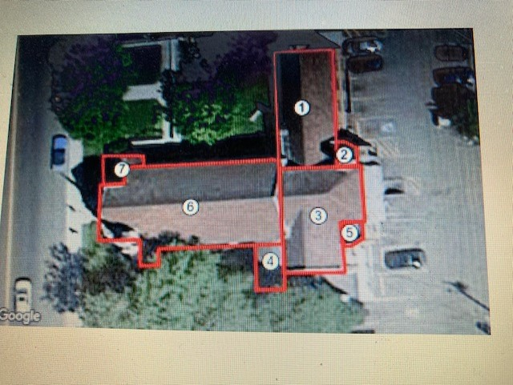

The church was divided into 7 sections (See report: Total Sq Ft: 5,542)
Map Name Sq Ft Est Install
Section 1 1,240
Section 2 85
Section 3 1,246
Section 4 205
Section 5 70
Section 6 2,550
Section 7 146
In the report It was clear that a grade of an F on certain sections required that the roof be repaired and/or replaced. In keeping with the architectural and historical features of the church the decision was made by the Chapter in 2021 to use the architectural slate tiles from the same manufacturer who made the original tiles. This was to embrace and keep the historical significance of our beautiful church intact. An RFP was sent to a number of contractors as recommended by the architect. A contract was awarded for the part of the roof that was badly in need of repair. Work was completed in June 2022 to sections 4 and 6 as noted above.
At this time sections 1-3, 5 and 7 for a total of approximately 3571 feet will be completed as necessary and as funds are available. An updated cost will be needed and a determination made as to whether we would want to reuse existing tile or purchase new tiles.

How much money has been spent to date on roof repair?
As of this writing, November 1, 2022 the total cost for the roof repair for sections 4 and 6 was $304,378.00. This includes the cost of the tiles, which was $69,439.54 as well as the architectural cost of $13,640.00

The evaluation and recommendations to repair or replace the Nave roof was received, bid, awarded and work completed by June 2022. Due to the urgency of the roof project, cost of materials increasing and supply chain issues the Chapter used church contingency resources to pay for this portion of the roof. These resources will need to be reimbursed from the Capital campaign funding.

What other monies has been spent and for what?
Cost of Capital Campaign materials provided by Crossman Whitney and Griffin PC (CWG architects) was an additional $5,145.00. These monies were taken from the Kelley Foundation planning grant awarded in January 2022.

Are there other Capital improvement projects anticipated? What other capital improvements could be included?
The capital needs committee identified other possible projects including:
- Capital Contingency Fund
- Security and fire alarm system, - some has already been donated
- Church ventilation system improvements
- Finish roof on the rest of the church building: need cost estimate, this will depend on how many tiles will need to be replaced
- Roof on Wilson Hall- will need to assessed and cost estimated
- Front steps to be replaced or repaired
- Solar and/or other renewable energy upgrades
- Landscaping- would want to know about in front of Wilson Hall and South of church

What will each improvement cost?
This will be dependent on when the cost estimate is completed. We have significant need for repairs in our infrastructure. Except for the boiler and the new hardwood floor in the undercroft, there has been no capital expenditures made to preserve and maintain our church in the last 90 years.

How much money needs to be raised from church members?
In order to address the significant needs, we face, the Next 100 years Capital Campaign will need to raise 1 million dollars. The majority of the money we raise will come from church membership, the Helena community, and beyond.

How much from grants?
A $10,000.00 planning grant from the Kelley Foundation was awarded January 2022. We have also had preliminary discussions with the Treacy Foundation for a capstone grant, the requested amount for this grant will depend on the amount raised. Other grants may become available. In July 2022 the church was invited to apply for a $100,000.00 matching grant from Partners for Sacred Places in collaboration with the National Trust for Historic Preservation. Unfortunately, on Oct 11, 2022 the church was notified that this grant was not awarded.

Are low-interest loans available?
At this time, we have no plans to entertain a low interest loan. We prefer to pay for these Capital improvements as we raise the money.

Can I agree to make payments to the next hundred years project over a period of time?
Yes, you’re welcome to make a one-time donation, or a pledged donation over a period of time of
your own choosing. The Next 100 years capital campaign will be ongoing for the next several years.

Can I use my required minimum distribution (RMD) to give to the campaign?
Yes, several parishioners have already given to the capital campaign utilizing their required minimum distribution (RMD).
Tom Morrison a tax planning attorney is available to answer any question you might have related to this type donation.

Where can I get additional information?
Please contact
Dan Carlson-Thompson
406 465 2022
danlizzie@msn.com
or
Dean Scott Anderson
406 437 2143
dean@spchelena.org

