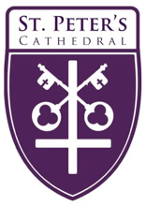
The Rt. Rev. Marty Stebbins, Bishop
The Very Rev. Kendra Wilde, Dean

Holy Baptism and
The Holy Eucharist

All Saints’ Day
November 2, 2025, 9:00 am & Livestreamed Online
Welcome to St. Peter’s Cathedral!

We’re delighted you’re here. Whether you’ve been here for years or it’s your first time with us, we hope you’ll find richness in offering your prayers and praise together during worship. And afterward, please join us downstairs to welcome the newly baptized and his family, and enjoy some pancakes. Whoever you are and wherever you come from, wherever you hurt, whatever you bring, and whatever you hope for today, you are welcome at Christ’s table and here at St. Peter’s.


Ministers Serving Today

Presider & preacher: The Very Rev. Kendra Wilde
Guest organist: Dr. Wendy Yuen
Acolytes: Audrey Towery & Vera Towery
Eucharistic Minister (EM): Aubrey Curtis
Eucharistic Visitors (EVs): Jennie Ekwortzel
Dan Carlson-Thompson
Lectors: Chris Stockwell & Bill Shropshire
Ushers: Gretchen Hibbard & Scott Hibbard

A few things …

We draw our liturgy from a variety of approved resources.
Please see endnotes for sources and permissions.

The People’s responses
are printed in boldface.

Please silence cellphones

Prelude Prelude in G Major, BWV 541 Johann Sebastian Bach (1865-1750)

Opening Hymn, H-287 For all the Saints Tune: Sine Nomine

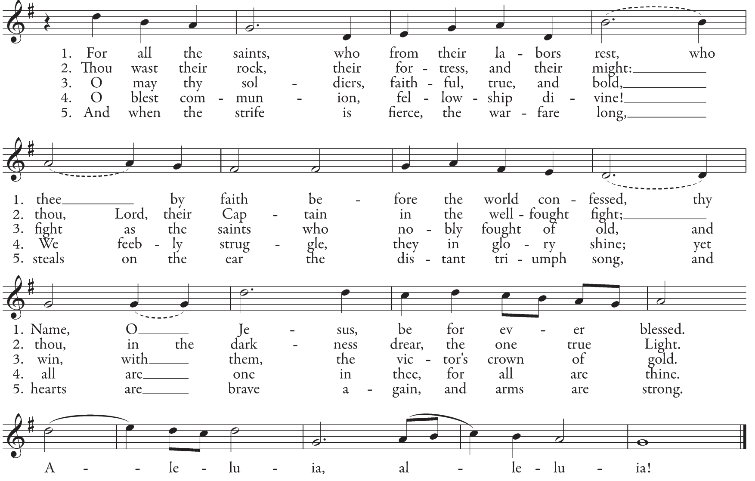

Opening Acclamation

Blessed be God: Father, Son, and Holy Spirit. BCP 299
And blessed be God’s kingdom now and for ever. Amen.
There is one Body and one Spirit;
There is one hope in God’s call to us;
One Lord, one Faith, one Baptism;
One God and Father of all.

The Gloria Jaques Berthier (1923-1994)
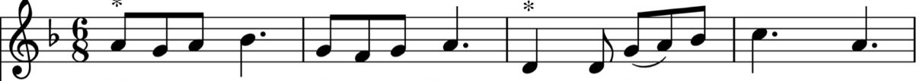

Glo - ri - a! Glo - ri - a! In ex - cel - sis De - o.
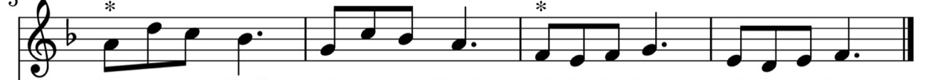

Glo - ri - a! Glo - ri - a! Al - le - lu - ia! Al - le - lu - ia!
The Collect of the Day BCP 245

God be with you. And also with you. Let us pray.

Almighty God, you have knit together your elect in one communion and fellowship in the mystical body of your Son Christ our Lord: Give us grace so to follow your blessed saints in all virtuous and godly living, that we may come to those ineffable joys that you have prepared for those who truly love you; through Jesus Christ our Lord, who with you and the Holy Spirit lives and reigns, one God, in glory everlasting. Amen.

The Reading from the Old Testament Daniel 7:1-3, 15-18

In the first year of King Belshazzar of Babylon, Daniel had a dream and visions of his head as he lay in bed. Then he wrote down the dream: I, Daniel, saw in my vision by night the four winds of heaven stirring up the great sea, and four great beasts came up out of the sea, different from one another. As for me, Daniel, my spirit was troubled within me, and the visions of my head terrified me. I approached one of the attendants to ask him the truth concerning all this. So he said that he would disclose to me the interpretation of the matter: “As for these four great beasts, four kings shall arise out of the earth. But the holy ones of the Most High shall receive the kingdom and possess the kingdom for ever—for ever and ever.”

The Word of the Lord.
Thanks be to God.

The Response Psalm 149:1-5 (Alternating by whole verse)

¹ Hallelujah! Sing to the Lord a new song; *
sing his praise in the congregation of the faithful.

² Let Israel rejoice in his Maker; *
let the children of Zion be joyful in their King.

³ Let them praise his Name in the dance; *
let them sing praise to him with timbrel and harp.

⁴ For the Lord takes pleasure in his people *
and adorns the poor with victory.

⁵ Let the faithful rejoice in triumph; *
let them be joyful on their beds.

The Reading from the New Testament Ephesians 1:11-23

In Christ we have also obtained an inheritance, having been destined according to the purpose of him who accomplishes all things according to his counsel and will, so that we, who were the first to set our hope on Christ, might live for the praise of his glory. In him you also, when you had heard the word of truth, the gospel of your salvation, and had believed in him, were marked with the seal of the promised Holy Spirit; this is the pledge of our inheritance toward redemption as God’s own people, to the praise of his glory. I have heard of your faith in the Lord Jesus and your love toward all the saints, and for this reason I do not cease to give thanks for you as I remember you in my prayers. I pray that the God of our Lord Jesus Christ, the Father of glory, may give you a spirit of wisdom and revelation as you come to know him, so that, with the eyes of your heart enlightened, you may know what is the hope to which he has called you, what are the riches of his glorious inheritance among the saints, and what is the immeasurable greatness of his power for us who believe, according to the working of his great power. God put this power to work in Christ when he raised him from the dead and seated him at his right hand in the heavenly places, far above all rule and authority and power and dominion, and above every name that is named, not only in this age but also in the age to come. And he has put all things under his feet and has made him the head over all things for the church, which is his body, the fullness of him who fills all in all.

The Word of the Lord.
Thanks be to God.

The Sequence Baptized in water Tune: Bunessan

The Proclamation of the Gospel Luke 6:20-31

The Holy Gospel of our Lord Jesus Christ according to Luke.
Glory to you, Lord Christ.

Jesus looked up at his disciples and said:
“Blessed are you who are poor,
for yours is the kingdom of God.
“Blessed are you who are hungry now,
for you will be filled.
“Blessed are you who weep now,
for you will laugh.
“Blessed are you when people hate you, and when they exclude you, revile you, and defame you on account of the Son of Man. Rejoice in that day and leap for joy, for surely your reward is great in heaven; for that is what their ancestors did to the prophets.”

“But woe to you who are rich,
for you have received your consolation.
“Woe to you who are full now,
for you will be hungry.
“Woe to you who are laughing now,
for you will mourn and weep.
“Woe to you when all speak well of you, for that is what their ancestors did to the false prophets.”

“But I say to you that listen, Love your enemies, do good to those who hate you, bless those who curse you, pray for those who abuse you. If anyone strikes you on the cheek, offer the other also; and from anyone who takes away your coat do not withhold even your shirt. Give to everyone who begs from you; and if anyone takes away your goods, do not ask for them again. Do to others as you would have them do to you.”

The Gospel of the Lord.
Praise to you, Lord Christ.

The Sermon The Very Rev. Kendra Wilde

Presentation and Examination of the Baptismal Candidates BCP 301

Presider The Candidate for Holy Baptism will now be presented.

Parents and Godparents

I present Thomas to receive the Sacrament of Baptism.

The Presider asks the following of the Parents and Godparents

Presider Will you be responsible for seeing that Thomas is brought up in the Christian faith and
life?

Parents and Godparents

I will, with God’s help.

Presider Will you by your prayers and witness help Thomas to grow into the full stature of
Christ?

Parents and Godparents

I will, with God’s help.

The Presider asks the following of the parents and godparents who speak on behalf of the child

Question Do you renounce Satan and all the spiritual forces of wickedness that rebel against God?
Answer I renounce them.

Question Do you renounce the evil powers of this world which corrupt and destroy the creatures of God?
Answer I renounce them.

Question Do you renounce sinful desires that draw you from the love of God?
Answer I renounce them.

Question Do you turn to Jesus Christ and accept him as your Savior?
Answer I do.

Question Do you put your whole trust in his grace and love?
Answer I do.

Question Do you promise to follow and obey Jesus as your Lord?
Answer I do.

Will you who witness these vows do all in your power to support Thomas in his life in Christ?

People We will.

Let us join those committing themselves to Christ and renew our own baptismal covenant.

The Baptismal Covenant BCP 304

Presider Do you believe in God the Father?
People I believe in God, the Father almighty, creator of heaven and earth.

Do you believe in Jesus Christ, the Son of God?
I believe in Jesus Christ, his only Son, our Lord.
He was conceived by the power of the Holy Spirit
and born of the Virgin Mary.
He suffered under Pontius Pilate,
was crucified, died, and was buried.
He descended to the dead.
On the third day he rose again.
He ascended into heaven,
and is seated at the right hand of the Father.
He will come again to judge the living and the dead.

Do you believe in God the Holy Spirit?
I believe in the Holy Spirit,
the holy catholic Church,
the communion of saints,
the forgiveness of sins,
the resurrection of the body,
and the life everlasting.
Will you continue in the apostles’ teaching and fellowship, in the breaking of bread, and in the
prayers?
I will, with God’s help.

Will you persevere in resisting evil, and, whenever you fall into sin, repent and return to the Lord?
I will, with God’s help.

Will you proclaim by word and example the Good News of God in Christ?
I will, with God’s help.

Will you seek and serve Christ in all persons, loving your neighbor as yourself?
I will, with God’s help.

Will you strive for justice and peace among all people, and respect the dignity of every human
being?
I will, with God’s help.

Prayers for the Candidate BCP 305

Let us pray for Thomas who is to receive the Sacrament of new birth.

Leader Deliver him, O Lord, from the way of sin and death.
People Lord, hear our prayer.

Open his heart to your grace and truth.
Lord, hear our prayer.

Fill him with your holy and life-giving Spirit.
Lord, hear our prayer.

Keep him in the faith and communion of your holy Church.
Lord, hear our prayer.

Teach him to love others in the power of the Spirit.
Lord, hear our prayer.

Send him into the world in witness to your love.
Lord, hear our prayer.

Bring him to the fullness of your peace and glory.
Lord, hear our prayer.

Presider

Grant, O Lord, that all who are baptized into the death of Jesus Christ your Son may live in the power of his resurrection and look for him to come again in glory; who lives and reigns now and for ever. Amen.

Procession to the font I sing a song of the saints of God (Stanza one only) Tune: Grand Isle
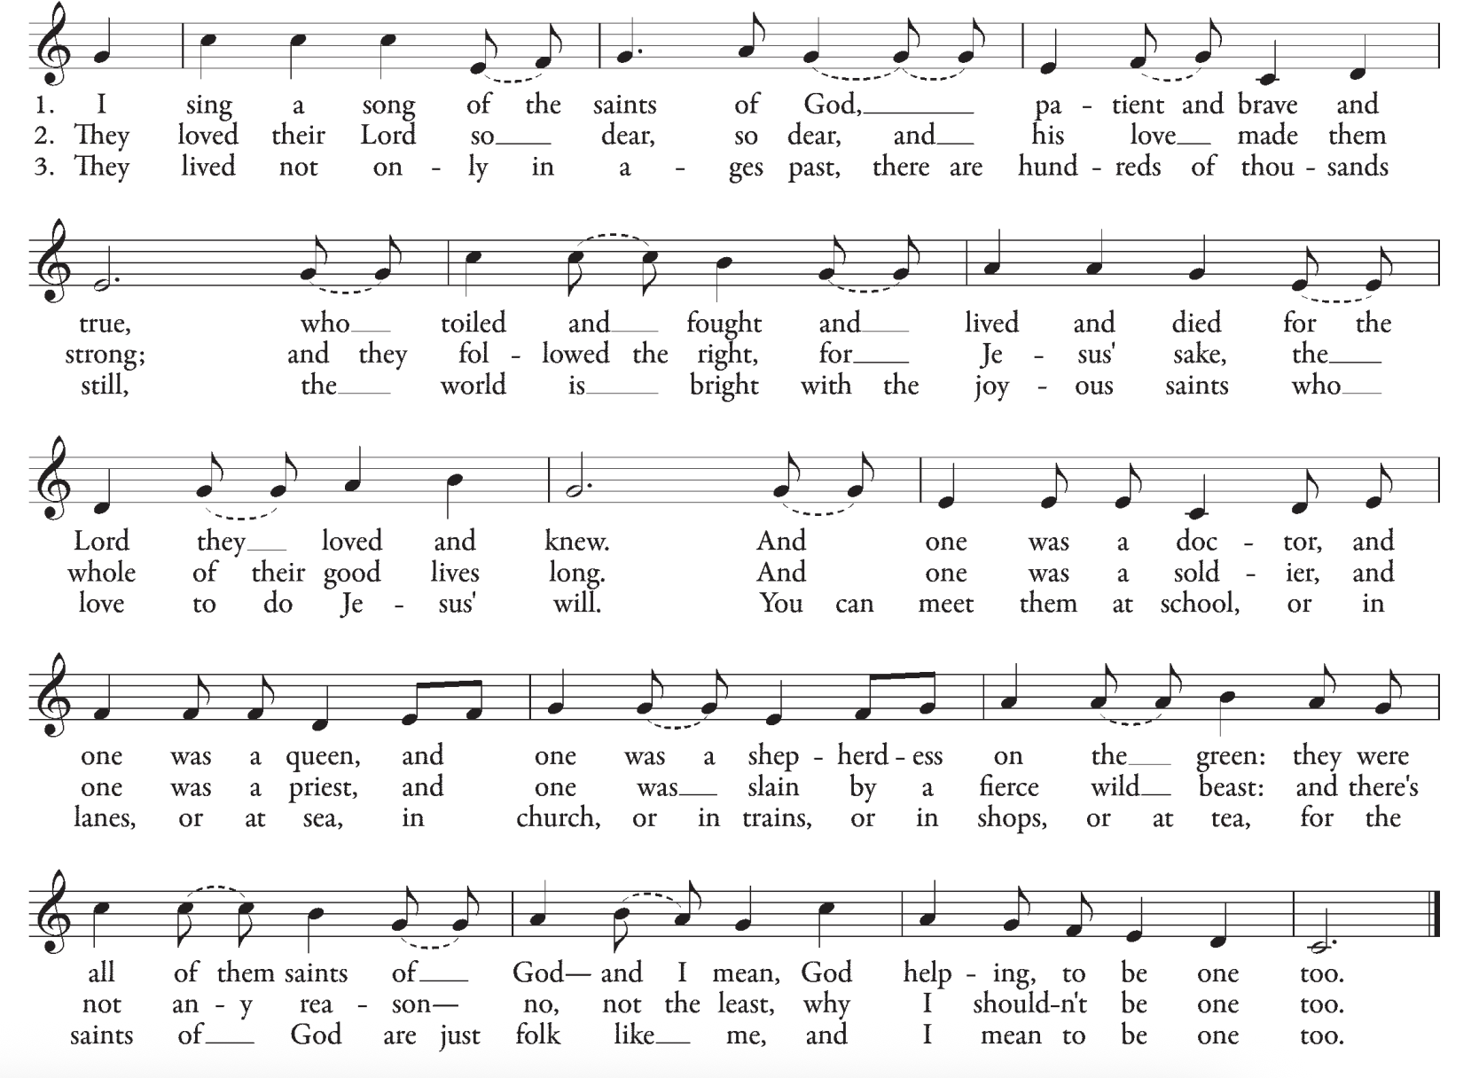

Thanksgiving over the Water BCP 306

God be with you.
And also with you.
Let us give thanks to the Lord our God.
It is right to give God thanks and praise.

We thank you, Almighty God, for the gift of water. Over it the Holy Spirit moved in the beginning of creation. Through it you led the children of Israel out of their bondage in Egypt into the land of promise. In it your Son Jesus received the baptism of John and was anointed by the Holy Spirit as the Messiah, the Christ, to lead us, through his death and resurrection, from the bondage of sin into everlasting life. We thank you, Father, for the water of Baptism. In it we are buried with Christ in his death. By it we share in his resurrection. Through it we are reborn by the Holy Spirit. Therefore in joyful obedience to your Son, we bring into his fellowship those who come to him in faith, baptizing them in the Name of the Father, and of the Son, and of the Holy Spirit.

Now sanctify this water, we pray you, by the power of your Holy Spirit, that those who here are cleansed from sin and born again may continue for ever in the risen life of Jesus Christ our Savior. To him, to you, and to the Holy Spirit, be all honor and glory, now and for ever. Amen.

The Baptism

The candidate is presented by name to the Celebrant, who pours water upon him saying

Thomas Child of God, I baptize you in the Name of the Father, and of the Son, and of the Holy Spirit. Amen.

When this action is completed, the Priest, in full sight of the congregation, prays over them, saying

Let us pray. Heavenly Father, we thank you that by water and the Holy Spirit you have bestowed upon this your servant the forgiveness of sin, and have raised him to the new life of grace. Sustain him, O Lord, in your Holy Spirit. Give him an inquiring and discerning heart, the courage to will and to persevere, a spirit to know and to love you, and the gift of joy and wonder in all your works. Amen.

Then the priest marks his forehead with the sign of the cross, using Chrism, and saying

Thomas Child of God, you are sealed by the Holy Spirit in Baptism and marked as Christ’s own for ever. Amen.

The newly baptized is given a baptismal candle

Presider May your light shine with the light of Christ.
Let us welcome the newly baptized, saying

All We receive you into the household of God.
Confess the faith of Christ crucified,
proclaim his resurrection,
and share with us in his eternal priesthood.

The Peace

The peace of the Lord be always with you.
And also with you.

The Asperges

The Necrology is recited

THE HOLY COMMUNION
The Offertory Sentence

The Offertory Hymn, H-593 Lord, make us servants of thy peace Tune: Dickinson College

The Great Thanksgiving

The Lord be with you.
And also with you.
Lift up your hearts.
We lift them to the Lord.
Let us give thanks to the Lord our God.
It is right to give our thanks and praise.

It is right, and a good and joyful thing, always and everywhere to give thanks to you, Father Almighty, Creator of heaven and earth. For by water and the Holy Spirit you have made us a new people in Jesus Christ our Lord, to show forth your glory in all the world.

We praise you and we bless you, holy and gracious God, source of life abundant. From before time you made ready the creation. Your Spirit moved over the deep and brought all things into being: sun, moon, and stars; earth, winds, and waters; and every living thing. You made us in your image, and taught us to walk in your ways. But we rebelled against you, and wandered far away; and yet, as a mother cares for her children, you would not forget us. Time and again you called us to live in the fullness of your love. And so this day we join with Saints and Angels in the chorus of praise that rings through eternity, lifting our voices to magnify you as we sing:

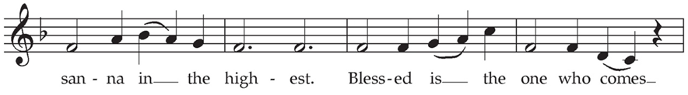
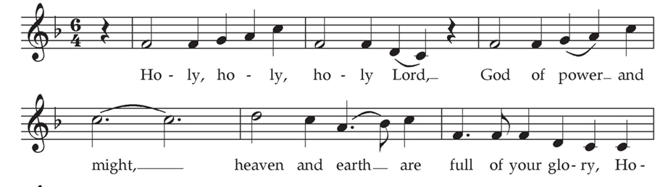

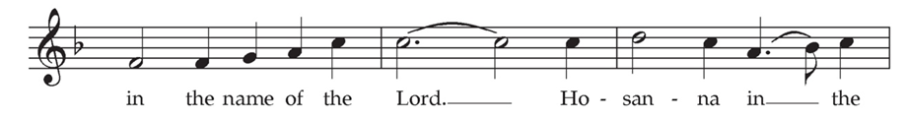
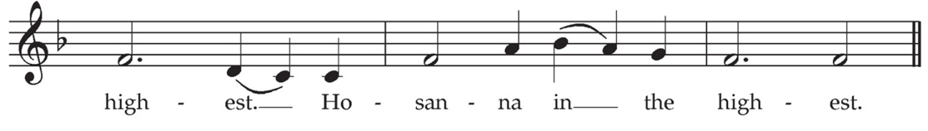

Glory and honor and praise to you, holy and living God. To deliver us from the power of sin and death and to reveal the riches of your grace, you looked with favor upon Mary, your willing servant, that she might conceive and bear a son, Jesus the holy child of God. Living among us, Jesus loved us. He broke bread with outcasts and sinners, healed the sick, and proclaimed good news to the poor. He yearned to draw all the world to himself yet we were heedless of his call to walk in love. Then, the time came for him to complete upon the cross the sacrifice of his life, and to be glorified by you.

On the night before he died for us, our Lord Jesus Christ took bread; and when he had given thanks to you, he broke it, and gave it to his disciples, and said, “Take, eat: This is my Body, which is given for you. Do this for the remembrance of me.” After supper he took the cup of wine; and when he had given thanks, he gave it to them, and said, “Drink this, all of you: This is my Blood of the new Covenant, which is shed for you and for all for the forgiveness of sins. Whenever you drink it, do this for the remembrance of me.”

Now gathered at your table, O God of all creation, and remembering Christ, God-with-us, crucified and risen, who was and is and is to come, we offer to you our gifts of bread and wine, and ourselves, a living sacrifice. Pour out your Spirit upon these gifts that they may be the Body and Blood of Christ. Breathe your Spirit over the whole earth and make us your new creation, the Body of Christ given for the world you have made. In the fullness of time bring us, with all your saints, from every tribe and language and people and nation, to feast at the banquet prepared from the foundation of the world.
Through Christ and with Christ and in Christ, in the unity of the Holy Spirit, to you be honor, glory, and praise, for ever and ever. AMEN.

And now, as our Savior Christ has taught us, we are bold to say,

Our Father, who art in heaven, hallowed be thy Name, thy kingdom come, thy will be done, on earth as it is in heaven. Give us this day our daily bread. And forgive us our trespasses, as we forgive those who trespass against us. And lead us not into temptation, but deliver us from evil. For thine is the kingdom, and the power, and the glory, for ever and ever. Amen.

The Breaking of the Bread

The Bread is broken and silence is observed

The Fraction Anthem (Spoken)

We break this bread to share in the Body of Christ.
We who are many are one body, for we all share in the one bread

The Prayer for Spiritual Communion offered by the Presider for those participating remotely

Organ interlude

Hymn I sing a song of the saints of God Tune: Grand Isle

Hymn Surely it is God who saves me Tune: Thomas Merton

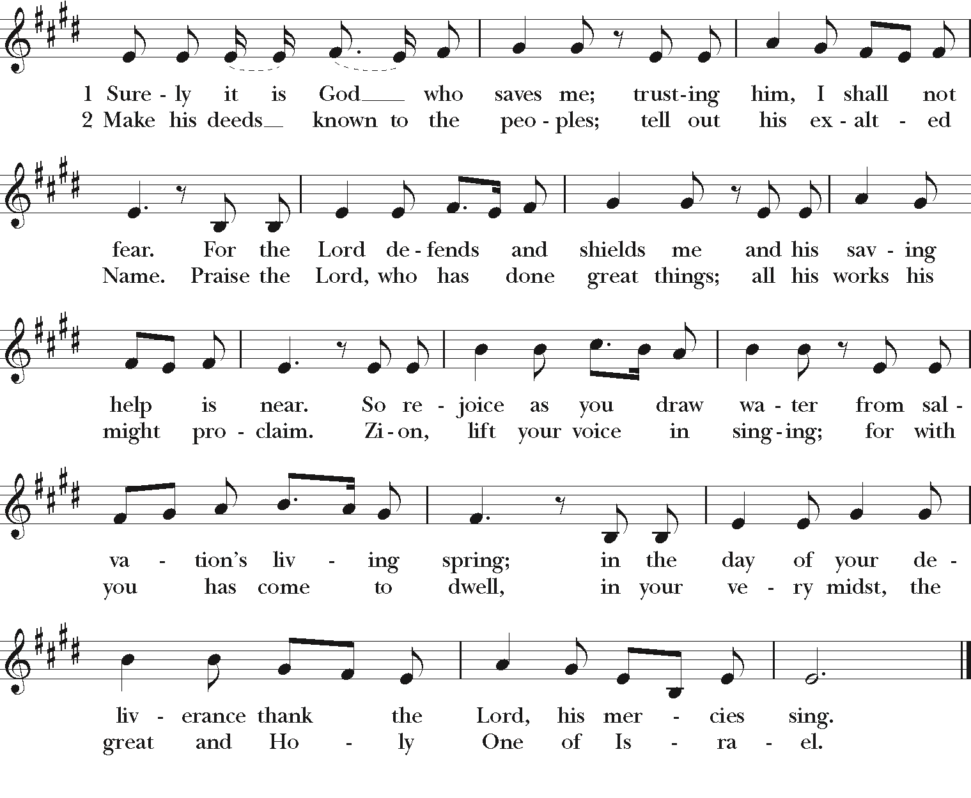

Organ interlude

The Post Communion Prayer

Let us pray. God of abundance, you have fed us with the bread of life and cup of salvation; you have united us with Christ and one another; and you have made us one with all your people in heaven and on earth. Now send us forth in the power of your Spirit, that we may proclaim your redeeming love to the world and continue for ever in the risen life of Christ our Savior. Amen.

The Eucharistic Visitor Sending

In the name of Christ and this congregation, we send Jennie and Dan forth bearing these holy gifts, that Mike and Steve Matross may share with us in the communion of Christ’s body and blood.
We who are many are one body, for we all share one bread, one cup.

The Announcements

The Blessing

The Closing Hymn, H-618 Ye watchers and ye holy ones Tune: Lasst uns enfreuen
The Dismissal

The Postlude Fugue in G, BWV 541 Johann Sebastian Bach (1865-1750)



Copyrighted Materials: All rights reserved. Unless otherwise noted, music is reproduced and/or broadcast under OneLicense.net A-727892. Hymn permission by Rite Song is a one-time reprint license for congregational use. Opening Hymn: For all the saints. Words: William Walsham How (1823-1897) Music: Sine nomine, Ralph Vaughan Williams (1872-1958), Hymnal 1982, © Church Hymnal Corp., 1985. Gloria: Tune: Jacques Berthier (1923-1994), © 1979, 1988, Les Presses de Taize, GIA Pub., agent; Sequence hymn, Baptized in water. Text Michael Sawand (1932-2015 c 1982, Hope Publishing Co. Music: Bunenssan; Gaelic melody; acc. by Marty Haugern, b. 1950 © 1987, GIA Publications, Inc., from Gather Hymnal, GIA Publications, 1994. Procession to the font: I sing a song of the saints of God. Words: Lesbia Scott (1998-1987), alt. Music: Grand Isle, John Henry Hopkins (1861-1945) Hymnal 1982, © Church Hymnal Corp., 1985. Offertory Hymn: Lord make us servants of thy peace. Words: James Quinn, SJ (1919-2010), based on prayer att. Francis of Assisi (1182-1226). Music: Dickinson College, Lee Hastings Bristol, Jr. (1923-1979), Hymnal 1982, © Church Hymnal Corp., 1985. Sanctus and Benedictus: Tune: Land of Rest, adapt. Marcia Pruner, © 1980, Church Pension Fund; acc. by Richard Proulx © 1986, GIA Publications, Inc., Gather Hymnal, GIA Publications, 1994. Communion Hymns: I sing a song (See above, Procession to the Font); and Surely it is God who saves me, Words: Carl P. Daw, Jr (b. 1944); para. of The First Song of Isaiah, Music: Thomas Merton, Ray W. Urwin (b. 1950) Hymnal 1982, © Church Hymnal Corp., 1985. Closing Hymn: Ye watchers and ye holy ones, Words: John Athelstan Laurie Riley (1858-1945). Music: Lasst uns erfreuen, melody from Auserlesene Catholische Greistliche Kirchengeseng, 1623, adapt. and harm. Ralph Vaughan Williams (1872-1958). Old Testament, New Testament and Gospel Lessons: From The New Revised Standard Version Bible © 1989, the Division of Christian Education of the National Council of the Churches of Christ in the USA. Used by permission. Psalm and Liturgical texts (except as noted below) are from The Book of Common Prayer © Church Pension Fund. Reprinted by permission. The Great Thanksgiving and the Post Communion Prayer, Enriching Our Worship, Vol. 1, Church Publishing, Inc., 1998. The Eucharistic Visitor Sending, Enriching Our Worship, Vol. 2, Church Publishing, Inc., 2000.

Please note: Photography and video recording may be in process while you are at the Cathedral. Entry into the facility signifies your release and consent to the possibility that your image may be used by the Cathedral for promotional purposes.

Next Week’s Liturgical Ministers

Presider & preacher: The Very Rev. Kendra Wilde
Piano: Patty Dean
Acolyte: Annalee Curtis
Eucharistic Minister (EM): Hope Stockwell
Eucharistic Visitors (EVs): Donna Church & Chris Boyce
Barb & Manny Hoag & Maggie Stockwell
Lectors: Patty Dean & Matt Jaynes
Ushers: Marsha Baumeister & Cathy Morris

Liturgical Note: What is Holy Baptism?

Holy Baptism and Holy Eucharist are the two great sacraments Christ gives to his Church. “Holy Baptism is full initiation by water and the Holy Spirit into Christ’s Body the Church. The bond which God establishes in Baptism is indissoluble” (Book of Common Prayer 298). During the rite of Holy Baptism, after the act of baptism itself, the priest anoints the newly baptized with oil and says, “You are sealed by the Holy Spirit in Baptism and marked as Christ’s own forever” (BCP 309). “… marked as Christ’s own forever” …. There may be no words more beautiful to the Christian’s ear.

In case of emergency, any baptized person may administer Baptism (BCP 313), but because it is such an important and joyful occasion, the Baptism is, whenever possible, celebrated within the bounds of the church’s rites, in the arms of the gathered community.

There are six occasions the Episcopal Church deems especially appropriate for Holy Baptism and one of those is All Saints’ Day (BCP 312). (All Saints’ Day, Nov. 1, is an occasion to celebrate all Christians, from all times. It also may be celebrated on the Sunday after Nov. 1—which is today!) All Saints’ Day is particularly apt for celebration of Holy Baptism, because Baptism is reception into the communion of saints, which is the body of all Christians past, present, and future. Just as the Church understands every Eucharistic feast as a banquet that unites—in a single sacramental liturgy—those who dwell in heaven and those who dwell on earth, Holy Baptism also transcends earthly time. The sacraments unite us in kairos time, God’s time of eternity.

You can find more of the Episcopal Church’s invitation to learning about the sacrament of Holy Baptism in The Catechism, in the BCP, particularly on pages 857-858 … well worth your time!

Q: What are the sacraments?
A: The sacraments are outward and visible signs of inward and spiritual grace, given by Christ as sure and certain means by which we receive that grace.

Q: What is grace?
A: Grace is God’s favor towards us, unearned and undeserved; by grace God forgives our sins, enlightens our minds, stills our hearts, and strengthens our wills.

Q: What are the two great sacraments of the Gospel?
A: The two great sacraments given by Christ to his Church are Holy Baptism and the Holy Eucharist.

Q: What is Holy Baptism?
A. Holy Baptism is the sacrament by which God adopts us as his children and makes us members of Christ’s Body, the Church, and inheritors of the kingdom of God.

Q: What is the outward and visible sign in Baptism?
A: The outward and visible sign in Baptism is water in which the person is baptized in the Name of the Father, and of the Son, and of the Holy Spirit.

Q: What is the inward and spiritual grace in Baptism?
A: The inward and spiritual grace in Baptism is union with Christ in his death and resurrection, birth into God’s family the Church, forgiveness of sins, and new life in the Holy Spirit.

More questions? Your cathedral clergy always welcome them. We may not always have answers, but we’d be delighted to respond, engage in conversation, and share the gift of Christian learning, teaching, and experience that we call formation. Give us a try!

