

**The Rt. Rev. Marty Stebbins, Bishop**

**The Very Rev. Kendra Wilde, Dean**

**The Holy Eucharist**

**The Nineteenth Sunday after Pentecost:**

**October 19, 2025, 9:00 am & Livestreamed Online**

***Welcome to St. Peter’s Cathedral!***

*We’re delighted you’re here. Whether you’ve been here for years or it’s your first time with us, we hope you’ll find richness in offering your prayers and praise during worship. And afterward, please join us downstairs for snacks. Whoever you are and wherever you come from, wherever you hurt today, whatever you bring today, you are welcome at Christ’s table and here at St. Peter’s.*



*We draw our liturgy from a variety of approved resources.*

*Please see endnotes for sources and permissions.*

***The People’s responses***

***are printed in boldface.***

**Ministers Serving Today**

Presider: *The Very Rev. Kendra Wilder*

Organist: *John Goodwin*

Acolyte: *Joel Robison*

Eucharistic Minister (EM): *Lizzie Carlson-Thompson*

Lectors: *Melinda Schell & Darien Scott*

Ushers: *Sam Gilbert & Donna Lloyd*

**Prelude**

**Hymn, H-709** *O God of Bethel* Tune: *Dundee*

**The Word of God**

**The Opening Acclamation**

Blessed be God: Father, Son, and Holy Spirit.

**And blessed be his kingdom, now and for ever. Amen.**

**The Opening Collect**

Almighty God, to you all hearts are open, all desires known, and from you no secrets are hid: Cleanse the thoughts of our hearts by the inspiration of your Holy Spirit, that we may perfectly love you, and worthily magnify your holy Name; through Christ our Lord. **Amen*.***

**The Gloria** Jaques Berthier (1923-1994)

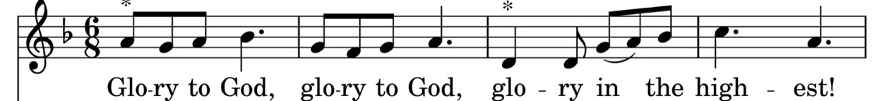



Glo - ri - a! Glo - ri - a! In ex - cel - sis De - o.

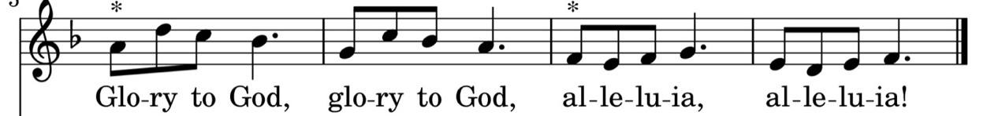

Glo - ri - a! Glo - ri - a! Al - le - lu- a! Al - le - lu- a!

**The Collect of the Day**

The Lord be with you.

**And also with you*.***

Let us pray.

Almighty and everlasting God, in Christ you have revealed your glory among the nations: Preserve the works of your mercy, that your Church throughout the world may persevere with steadfast faith in the confession of your Name; through Jesus Christ our Lord, who lives and reigns with you and the Holy Spirit, one God, for ever and ever. **Amen***.*

**The Old Testament Reading Jeremiah 31:27-34**

The days are surely coming, says the Lord, when I will sow the house of Israel and the house of Judah with the seed of humans and the seed of animals. And just as I have watched over them to pluck up and break down, to overthrow, destroy, and bring evil, so I will watch over them to build and to plant, says the Lord. In those days they shall no longer say:

“The parents have eaten sour grapes,  
 and the children's teeth are set on edge.”

But all shall die for their own sins; the teeth of everyone who eats sour grapes shall be set on edge.

The days are surely coming, says the Lord, when I will make a new covenant with the house of Israel and the house of Judah. It will not be like the covenant that I made with their ancestors when I took them by the hand to bring them out of the land of Egypt—a covenant that they broke, though I was their husband, says the Lord. But this is the covenant that I will make with the house of Israel after those days, says the Lord: I will put my law within them, and I will write it on their hearts; and I will be their God, and they shall be my people. No longer shall they teach one another, or say to each other, “Know the Lord,” for they shall all know me, from the least of them to the greatest, says the Lord; for I will forgive their iniquity, and remember their sin no more.

The Word of the Lord.

**Thanks be to God.**

**The Response: Psalm 119: 97-104** (Metrical paraphrase) Tune: *The Eighth Tune*

**2. My study is in your decrees,**

**They make me wiser than my guide;**

**More than the elders know is mine,**

**In your commandments I abide.**

**4. Much sweeter to my taste, O Lord,**

**Than honey is your sure decree;**

**My mind grows wise thru your command**

**I hate false ways most bitterly.**

**1. My mind is on your law all day,**

**And in it, Lord, is my delight;**

**More than the wisdom of my foes**

**Is your commandment day and night.**

**3. Maintaining your word, I restrain**

**My feet from every evil way;**

**My heart does not shrink from your law,**

**For you have taught me day by day.**

**The New Testament*:* 2 Timothy 3:14 – 4:5**

As for you, continue in what you have learned and firmly believed, knowing from whom you learned it, and how from childhood you have known the sacred writings that are able to instruct you for salvation through faith in Christ Jesus. All scripture is inspired by God and is useful for teaching, for reproof, for correction, and for training in righteousness, so that everyone who belongs to God may be proficient, equipped for every good work. In the presence of God and of Christ Jesus, who is to judge the living and the dead, and in view of his appearing and his kingdom, I solemnly urge you: proclaim the message; be persistent whether the time is favorable or unfavorable; convince, rebuke, and encourage, with the utmost patience in teaching. For the time is coming when people will not put up with sound doctrine, but having itching ears, they will accumulate for themselves teachers to suit their own desires, and will turn away from listening to the truth and wander away to myths. As for you, always be sober, endure suffering, do the work of an evangelist, carry out your ministry fully.

The Word of the Lord.

**Thanks be to God.**

**The Alleluia** Jaques Berthier (1923-1994)

**The Gospel Proclamation**Luke 18:1-8

The Holy Gospel of our Lord Jesus Christ according to Luke. **Glory to you, Lord Christ.**

Jesus told his disciples a parable about their need to pray always and not to lose heart. He said, “In a certain city there was a judge who neither feared God nor had respect for people. In that city there was a widow who kept coming to him and saying, ‘Grant me justice against my opponent.’ For a while he refused; but later he said to himself, ‘Though I have no fear of God and no respect for anyone, yet because this widow keeps bothering me, I will grant her justice, so that she may not wear me out by continually coming.’” And the Lord said, “Listen to what the unjust judge says. And will not God grant justice to his chosen ones who cry to him day and night? Will he delay long in helping them? I tell you, he will quickly grant justice to them. And yet, when the Son of Man comes, will he find faith on earth?”

The Gospel of the Lord. **Praise to you, Lord Christ.**

**The Sermon** The Very Rev. Kendra Wilde

**The Nicene Creed**BCP 358

**We believe in one God, the Father, the Almighty, maker of heaven and earth, of all that is, seen and unseen.**

**We believe in one Lord, Jesus Christ, the only Son of God, eternally begotten of the Father, God from God, Light from Light, true God from true God, begotten, not made, of one Being with the Father. Through him all things were made. For us and for our salvation he came down from heaven: by the power of the Holy Spirit he became incarnate from the Virgin Mary, and was made man. For our sake he was crucified under Pontius Pilate; he suffered death and was buried. On the third day he rose again in accordance with the Scriptures; he ascended into heaven and is seated at the right hand of the Father. He will come again in glory to judge the living and the dead, and his kingdom will have no end.**

**We believe in the Holy Spirit, the Lord, the giver of life, who proceeds from the Father and the Son. With the Father and the Son he is worshiped and glorified. He has spoken through the Prophets. We believe in one holy catholic and apostolic Church. We acknowledge one baptism for the forgiveness of sins. We look for the resurrection of the dead, and the life of the world to come. Amen.**

**The Prayers of the People**

*In the course of the silence after each bidding, the People offer their own prayers, either silently or aloud*.

*Leader*

I ask your prayers for God’s people throughout the world; for Bishop Marty; for Dean Kendra; for this gathering; and for all ministers and people. Pray for the Church.

*Silence*

I ask your prayers for peace; for goodwill among nations; and for the well‑being of all people.

Pray for justice and peace.

*Silence*

I ask your prayers for those who suffer from poverty, illness, food insecurity, oppression, for those in prison, and for those who care for them. Pray for those in any need or trouble.

*Silence*

I ask your prayers for all who seek God, or a deeper knowledge of God. Pray that they may find and be found by God.

*Silence*

I ask your prayers for the departed [especially______________], Pray for those who have died.

**Prayer Requests**

**The Church**: Presiding Bishop Sean; Bishop Marty, Dean Kendra; Togendowagan Society and Elders Darcy and Dan; and St. John’s Butte, Jim Faye, Sr Warden.

**The Government:** Our President Donald; our Governor Greg; Congress, especially Ryan, Steve, Tim, and Troy. Area mayors Kelly, Vickie, and Wilmot.

**The Community:** Gods’ Love, Good Samaritan, Family Promise, Helena Food Share, Friendship Center, Head Start, & YWCA.

**Comfort, Healing & Hope:** Bob D., Dick & Billie, Janet, Matthew, Helen, Jennie, Peggy, Kevin, Ray, Terry, Melanie, Kerry, Barbara, Rory, Denice, Paul, Sarah, JoAnne, Bob, Jeff, Michael, Ann Dooling and family, Dave T., Darcy, Michael, Nancy, Karen, John, Jim, Sarah, Rachel, Gene, Barbara, John and Angela, Mickey

**Those Serving in our Armed Forces:** David Emineth, Shane Medley, Charles Lewis, Kenneth V Liston, and Parker Jones.

*Silence*

*Members of the congregation may ask the prayers*

*or the thanksgivings of those present*

I ask your prayers for_____________.

I ask your thanksgiving for__________.

*Silence*

Praise God for those in every generation

in whom Christ has been honored.

Pray that we may have grace to glorify

Christ in our own day.

*Silence*

*Presider*

For yours is the majesty, O Father, Son,

and Holy Spirit; yours is the kingdom

and the power and the glory, now and for ever. **Amen**.

**The confession** BCP 350

Let us confess our sins against God and our neighbor.

**Most merciful God, we confess that we have sinned against you in thought, word, and deed, by what we have done, and by what we have left undone. We have not loved you with our whole heart; we have not loved our neighbors as ourselves. We are truly sorry and we humbly repent. For the sake of your Son Jesus Christ, have mercy on us and forgive us; that we may delight in your will, and walk in your ways, to the glory of your Name.  Amen.**

**The Absolution**

**The Peace**

**The Announcements**

**The Prayer for birthdays** BCP 830

**Watch over your children, O Lord, as their days increase; bless and guide them wherever they may be. Strengthen them when they stand; comfort them when discouraged or sorrowful; raise them up if they fall; and in their hearts may your peace which passes understanding abide all the days of their lives; through Jesus Christ our Lord. Amen.**

**The Prayer for anniversaries**

**We thank you, most gracious God, for consecrating the marriage of *N.* and *N.* in Christ’s Name and presence. Lead them further in companionship with each other and with you. Give them grace to live together in love and fidelity, with care for one another. Strengthen them all our days, and bring them to that holy table where, with those we love, we will feast for ever in our heavenly home; through Jesus Christ our Lord. Amen.**

**The Holy Communion**

*The Offertory sentence*

**The Offertory Hymn, H-686**  *Come, thou fount of every blessing* Tune: *Nettleton*

**The Great Thanksgiving**

The Lord be with you. **And also with you.**

Lift up your hearts. **We lift them to the Lord.**

Let us give thanks to the Lord our God. **It is right to give him thanks and praise.**

It is right, and a good and joyful thing, always and everywhere to give thanks to you, Father Almighty, Creator of heaven and earth. For you are the source of light and life, you made us in your image, and called us to new life in Jesus Christ our Lord. Therefore we praise you, joining our voices with Angels and Archangels and with all the company of heaven, who for ever sing this hymn to proclaim the glory of your Name:

We give thanks to you, O God, for the goodness and love which you have made known to us in creation; in the calling of Israel to be your people; in your Word spoken through the prophets; and above all in the Word made flesh, Jesus, your Son. For in these last days you sent him to be incarnate from the Virgin Mary, to be the Savior and Redeemer of the world. In him, you have delivered us from evil, and made us worthy to stand before you. In him, you have brought us out of error into truth, out of sin into righteousness, out of death into life.

On the night before he died for us, our Lord Jesus Christ took bread; and when he had given thanks to you, he broke it, and gave it to his disciples, and said, “Take, eat: This is my Body, which is given for you. Do this for the remembrance of me.” After supper he took the cup of wine; and when he had given thanks, he gave it to them, and said, “Drink this, all of you: This is my Blood of the new Covenant, which is shed for you and for many for the forgiveness of sins. Whenever you drink it, do this for the remembrance of me.” Therefore, according to his command, O Father,

**We remember his death, We proclaim his resurrection, We await his coming in glory;**

And we offer our sacrifice of praise and thanksgiving to you, O Lord of all; presenting to you, from your creation, this bread and this wine. We pray you, gracious God, to send your Holy Spirit upon these gifts that they may be the Sacrament of the Body of Christ and his Blood of the new Covenant. Unite us to your Son in his sacrifice, that we may be acceptable through him, being sanctified by the Holy Spirit. In the fullness of time, put all things in subjection under your Christ, and bring us to that heavenly country where, with all your saints, we may enter the everlasting heritage of your sons and daughters; through Jesus Christ our Lord, the firstborn of all creation, the head of the Church, and the author of our salvation. By him, and with him, and in him, in the unity of the Holy Spirit all honor and glory is yours, Almighty Father, now and for ever. ***AMEN.***

And now, as our Savior Christ has taught us, we are bold to say,

**Our Father, who art in heaven, hallowed be thy Name, thy kingdom come, thy will be done, on earth as it is in heaven. Give us this day our daily bread. And forgive us our trespasses, as we forgive those who trespass against us. And lead us not into temptation, but deliver us from evil. For thine is the kingdom, and the power, and the glory, for ever and ever. Amen.**

**The Breaking of the Bread**

*Silence*

Alleluia. Christ our Passover is sacrificed for us. T**herefore let us keep the feast. Alleluia.**

The holy gifts of God for the holy people of God.

*Christ welcomes all to communion. ■ Receive the bread in open and outstretched hands and sip the wine, guiding the chalice to your lips. ■ If you do not want to sip the wine, it is also perfectly appropriate to receive the bread only. ■ You may respond to communion by saying “Amen.” ■ If you prefer a blessing, cross your hands over your chest. ■ Tell the minister if you require gluten-free elements. ■ In the Episcopal Church Baptism generally precedes communion and is offered several times a year; please speak to a member of the clergy to learn more. ■*

**The Prayer for Spiritual Communion** on behalf of those participating remotely

**Music at Communion**

**Organ Interlude**

**Hymn** *Sweet Hour of Prayer*

1. **Sweet hour of prayer! Sweet hour of prayer! That calls us from a world of care.**
2. **Sweet hour of prayer! Sweet hour of prayer! The joys I feel the bliss I share**
3. **Sweet hour of prayer! Sweet hour of prayer! thy wings shall my pe - ti - tion bear**

**1. And bids me at my fa - ther’s throne make all my wants and wish - es known. In**

**2. of those whose an - xious spi - rits burn with strong de-sires for thy re-turn! With**

**3. to him whose truth and faith - ful-ness en - gage the wait-ing soul to bless. And**

**1. sea - sons of dis - tress and grief; my soul has of - ten found re - lief, and**

**2. such I hast - en to the place where God my Sa - vior shows his face, and**

**3. since he bids me seek his face, be - lieve his word, and trust his grace, I’ll**

**1. oft es - caped the tempt – er’s snare by thy re - turn, sweet hour of prayer.**

**2. glad - ly take my sta - tion there, and wait for thee, sweet hour of prayer.**

**3. cast on him, my ev - ‘ry care, and wait for thee, sweet hour of prayer.**

**Hymn** *Standin’ in the Need of Prayer*

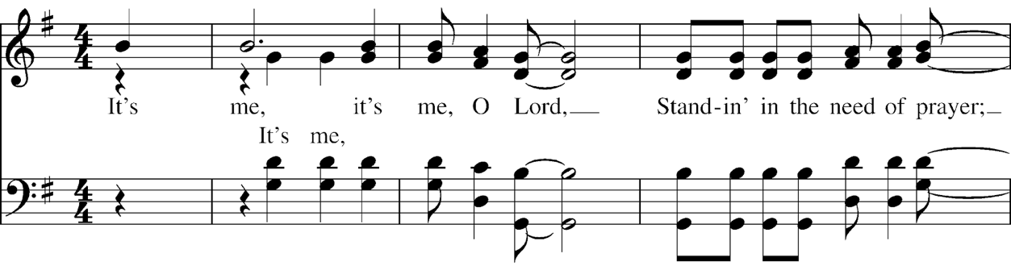

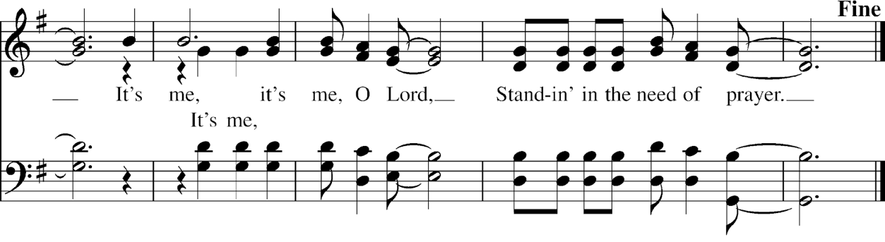  
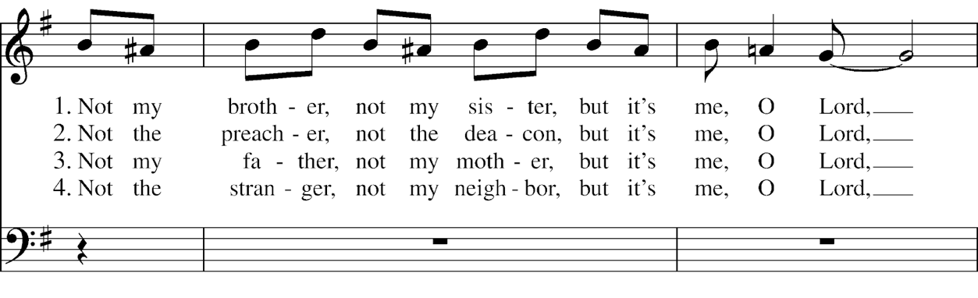  
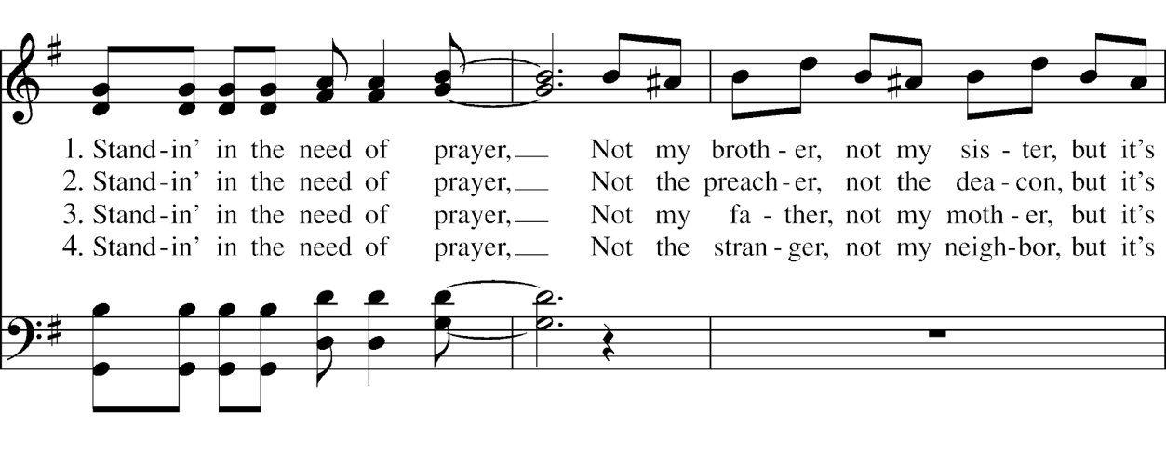  
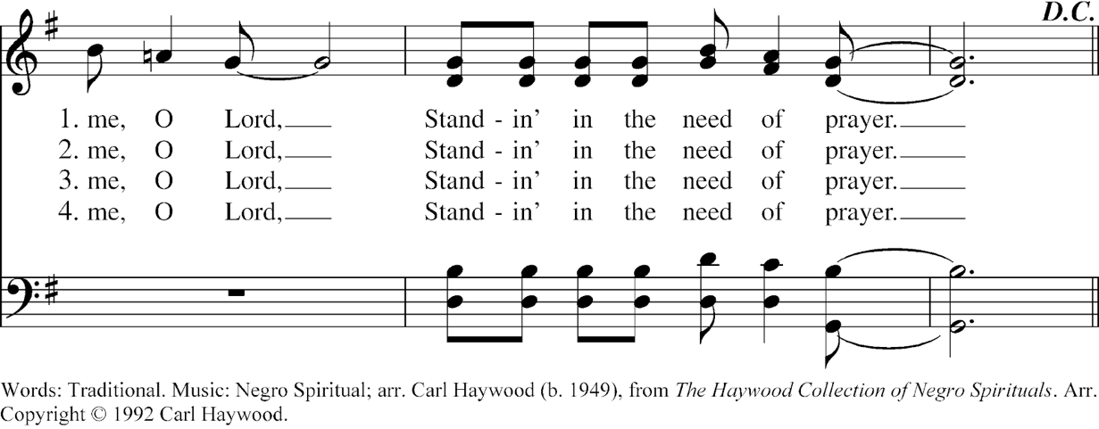

**Post Communion Prayer**

Let us pray.

**Eternal God, heavenly Father, you have graciously accepted us as living members of your Son our Savior Jesus Christ, and you have fed us with spiritual food in the Sacrament of his Body and Blood. Send us now into the world in peace, and grant us strength and courage to love and serve you with gladness and singleness of heart; through Christ our Lord. Amen.**

**Sending Forth of Eucharistic Ministers**

In the name of Christ and this congregation, we send *N.* and *N.* forth bearing these holy gifts, that *N.* may share with us in the communion of Christ’s body and blood.

**We who are many are one body, for we all share one bread, one cup.**

**The Children’s Moment The Very Rev. Kendra Wilde**

**The Blessing**

**Hymn, H-535** *Ye servants of God* Tune: *Paderborn*

**The Dismissal**

Go in peace to love and serve the Lord. **Thanks be to God.**

**Postlude**

Copyrighted Materials: All rights reserved. Unless otherwise noted, music is reproduced and/or broadcast under OneLicense.net A-727892. Hymn permissions used by Rite Song is a one-time use reprint license for congregational use. **♱ Opening Hymn**: *O God of Bethel*. **Words**: Philip Doddridge (1702-1751), alt. Music: *Dundee*, melody from *The CL Psalmes of David, 1615;* **Offertory Hymn:** *Come, thou fount*. Words: Robert Robinson (1735-1790), alt. Music: *Nettleton,* melody from *A Repository of Sacred Music, Part II,* 1813; **Closing Hymn:** *Ye servants of God*. Words: Charles Wesley (1707-1788), alt. Music: *Paderborn,* melody from *Catolisch-Paderbornicshes Gesang-buch*, 1765; harm. Sydney Hugo Nicholson (1875-1947); all from *Hymnal 1982,* © Church Hymnal Corp., 1985. **Communion** **hymns**: *Sweet Hour of Prayer.*  Words: William W. Walford (1772-1850). Music: *Land of Rest,* William Bradbury (1816-1868). In the public domain; *It’s me, oh Lord.* Words: Traditional. Music: Negro Spiritual; arr. Carol Haywood (b. 1949), from *The Haywood Collection of Negro Spirituals,* Copyright ©, 1992. **♱ Gloria** and **Alleluia**: Tune: Jacques Berthier, © 1979, 1988, Les Presses de Taize, GIA Pub., agent; **Sanctus and Benedictus**:Tune: *Land of Rest,* adapt. Marcia Pruner, © 1980, Church Pension Fund; acc. by Richard Proulx © 1986, GIA Publications, Inc.; all from *Gather 2nd ed.,* GIA Pub. © 1994. **♱ Liturgical texts**, except as noted, are from *The Book of Common Prayer* © Church Pension Fund. Reprinted by permission **♱ Anniversary blessing**, *Book of Occasional Services,* Church Publishing, 2022. **♱ Psalm**: *A New Metrical Psalter,* Christopher L. Webber, Church Hymnal Corporation, 1986. Used by permission in worship. Tune: *The Eighth Tune,* Thomas Tallis (1505?-1585) **♱ Old Testament**, **New Testament** and **Gospel** Lessons: From The New Revised Standard Version Bible © 1989, the Division of Christian Education of the National Council of the Churches of Christ in the USA. Used by permission. **♱** **Eucharistic Visitor Sending,** Enriching Our Worship, Vol. 2, Church Publishing, Inc., 2000.

When you enter a St. Peter’s Cathedral worship service, you enter an area where video recording may occur. St. Peter’s makes video recordings of members involved in church services. Staff and/or participants may use such video records to recall activities or participants. In addition, such audio/visual recordings may be used in St. Peter’s Cathedral’s for the streaming and website hosting of worship services. By entering the service premises, you consent to video recording and its release, to be used for live streaming by St. Peter’s Cathedral. You release St. Peter’s Cathedral, its clergy, church officers, employees, laity, and each and all persons involved from any liability connected with the taking, recording, digitizing, and/or publication of video recordings. By entering the service premises, you waive all rights you may have to any claims for payment or royalties in connection with any exhibition, streaming, webcasting, or other publication of these materials, regardless of the purpose. You also waive any right to inspect or approve any video recording taken by St. Peter’s Cathedral or the person or entity designated to do so by St. Peter’s Cathedral. You have been fully informed of your consent, waiver of liability, and release before entering the service/event.

HAPPENINGS

HAPPENINGS